**Lesson 2 – Power Electronics**

In this lesson we’ll be looking at how to power our rover. These concepts will apply to all kinds of robots, but since this is part of a series of workshop lessons, we’ll use our rover for all the examples. We’ll start out by discussing some electrical engineering theory, then design our rover’s power circuit on paper, and wrap up by building the circuit and installing it in our rover.

**Power Concepts**

Before we begin designing our circuit, it's important to quickly recap a few key concepts of electricity. Usually, when we’re trying to measure electricity or quantify how much of it there is, we use three particular terms:

|  |  |  |
| --- | --- | --- |
| **Term** | **Unit** | **Symbol in Equations** |
| Voltage, Electric Potential | Volts (V) | V |
| Current | Amps (A) | I |
| Power | Watts (W) | P |

There is a lot to learn about circuits, and many people through the years have done a [much better job explaining circuits](https://ataridogdaze.com/science/hydraulic/index.html) than we have time for here. we’ll focus on a few specific things that’ll be useful for creating our robot circuit:

1. The relationship between voltage, current, and power: P = V x I
2. For the electrical components we’ll use, the supply voltage they need is usually constant but the current they draw will vary depending on the device. A sensor and a microcontroller may both run at 5V, but the microcontroller will probably draw more current than the sensor.
3. When a power supply gives a power and/or current rating, that is the maximum it can safely supply. When a device or component has a rating, that is the maximum it will ever use.

To build safe and effective robots, we need to pay attention to these three points. When we fail to give a device the power it needs, it may work poorly or not work altogether. When we exceed the ratings of a power supply or device, it may break, get hot, and even catch fire. We need to be careful to select our batteries, components, and even our wires so they work safely and effectively together.

**Voltages**

The first thing we’ll do in designing our robot’s circuit is choose the voltages it should operate at. Lots of commercial-off-the-shelf (COTS) electronics- including the microcontroller and sensors we’ll be using- are designed to operate at 5V (3.3V is also common), so we know we’ll want 5V.

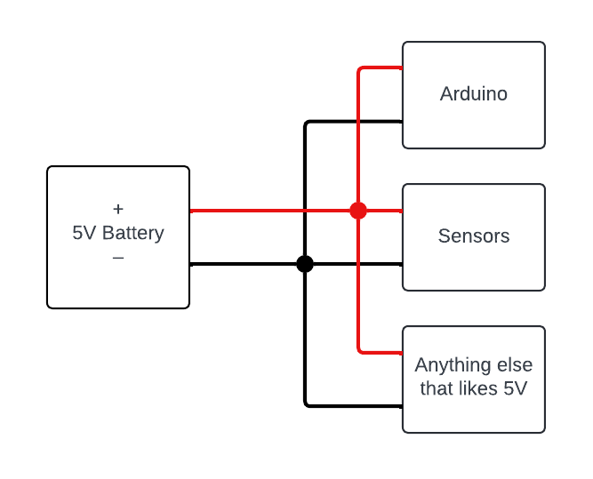

**Figure 2-1:** The most basic power electronics circuit

The challenge is finding a 5V battery. Because of how battery chemistry works, they don’t really exist. Even if they did, we still have motors that want more than 5V. We need to find a way of getting 5V from a battery that can’t supply 5V.

The solution to this problem is to use a *voltage regulator*. A regulator is a component that can take a variety of (usually higher) input voltages and convert it to (in our case) a steady 5V. That provides a convenient solution to our battery chemistry problem, but what should the input voltage to our regulator be?

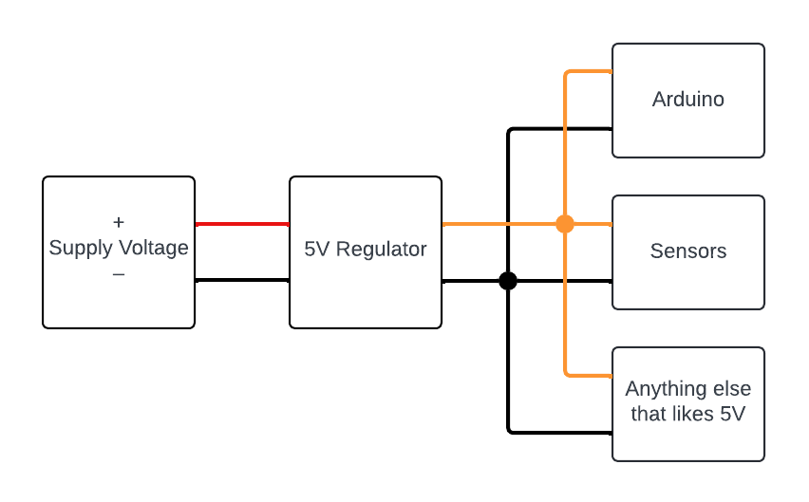

**Figure 2-2:** Using a 5V regulator to drop the supply voltage

We’ll call the input voltage to our regulator the *supply voltage*. The best way to select our supply voltage is to think about what else it could be used for besides supplying our regulator. We still need to supply power to our motors, so it makes sense to choose a supply voltage appropriate for that. The motors on our rover are designed to run at 12V. Conveniently, a 3-cell lithium-polymer (LiPo) battery produces approximately 12V, so we’ll use 12V as our supply voltage, branch off some for the motors, and send the rest to our 5V regulator to power our microcontroller, sensors, and such.

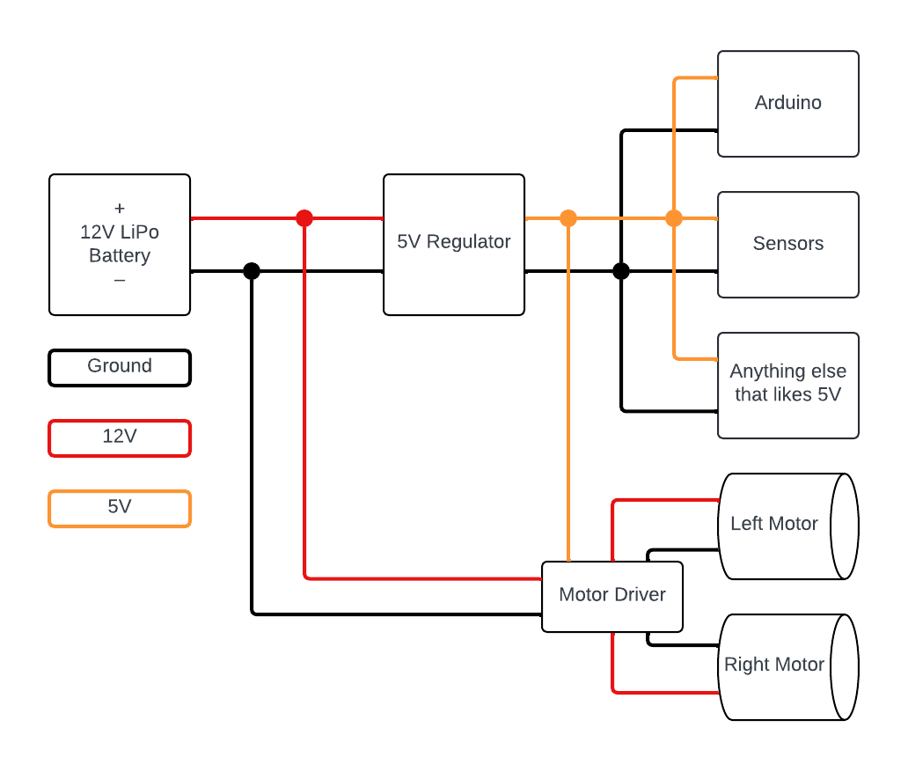

**Figure 2-3:** The complete power electronics circuit

You’ll see there's a device called a motor driver in this drawing that we haven’t talked about yet. It’s a nifty little component that we’ll talk about in the next lesson when we learn to make our robot move. For now, we’ll move on to learning about the currents in our system.

**Currents**

With the voltages our circuit operates at selected, we now need to consider the currents we’ll be dealing with. The currents our components draw will impact a lot of our design decisions. If we draw more current than our components are designed for, we could run out of battery, damage parts, or even start a fire. It is very important to be aware of the currents in your robot.

Luckily, designing around the currents your components draw isn’t too hard. A great place to start is to list all the 5V components your robot will have (we’ll discuss the 12V components in a minute) and find an estimate for the maximum current each component can draw. The best place to find that kind of information for a component is in its [*datasheet*](https://en.wikipedia.org/wiki/Datasheet), which is a document written by the manufacturer that describes the use and performance of a component. Any reputable manufacturer will provide datasheets for the components they make, which you can often find in the item description when you buy a component*.* Below is a list of 5V components on the workshop rover, with datasheets linked:

|  |  |  |
| --- | --- | --- |
| **Picture** | **Device** | **Estimated Current** |
|  | Arduino Nano V3.0 | [19 mA](https://docs.arduino.cc/resources/datasheets/A000005-datasheet.pdf) |
|  | Dual Motor Driver | [2.2 mA](https://www.sparkfun.com/datasheets/Robotics/TB6612FNG.pdf)  *This is the max logic supply current (I_cc), we consider motor current separately |
|  | HC-SR04 Ultrasonic Sensor | [15 mA](https://cdn.sparkfun.com/datasheets/Sensors/Proximity/HCSR04.pdf) |
|  | LM393 Infrared Sensor | [20 mA](https://www.ti.com/lit/ds/symlink/lm393.pdf?ts=1720696508544&ref_url=https%253A%252F%252Fwww.ti.com%252Fproduct%252FLM393%253Fbm-verify%253DAAQAAAAJ_____xEXrStGMcT1oUzn_MCJThj2WkYkLD3uJQLZVaGxdKtYx6z3O-MSRsA5fGm2eBkGDVmYiIpCyqP2D04Zdi9L9dWKt9hwKmZ_omEX8Mqw1mh5jt5ImEy_8_vIggH7dxDj0BKCpvhGyJWwqMnM8XSBxgBBN_qvCW8kJkA1vgd75dcTGHfLvkMcWezoY0XpbEj1V8fw9Mh1k6dyjzspAjCe_Xt5BDBuzcMCovFpgsO8pJktFIlJ344eUOHt0F3j83uH7mLy4lb7IprptbqMhQhku1EG)  *LM393 is not only power consumer; IR LED will consume most of the current |
|  | 9DOF Inertial Measurement Unit | [10 mA](https://invensense.tdk.com/wp-content/uploads/2016/06/DS-000189-ICM-20948-v1.3.pdf)  *Determining 5V current draw for this part is complicated due to its 1.8V logic level; this is an intentional over-estimate |
|  | Total 5V Current Draw: | 66.2 mA |

Our total current draw from our 5V regulator is simply the sum of the currents all these different parts will draw ([Kirchhoff's Junction Rule](https://en.wikipedia.org/wiki/Kirchhoff%27s_circuit_laws) for anyone who’s studied circuits)! In this case, our 5V regulator will need to supply 66.2 mA. For our calculations, we’ll round this total current up to 0.1A (100 mA) to be thorough.

Remember point #1 under power concepts? That was the relationship between voltage, current, and power:

$$P=V×I$$

We can use this relationship to find out how much power our 5V regulator needs to be able to supply. We know we want to supply 0.1A of current, and we want to supply that current at 5V. By applying the power relationship, we get 0.5W, so we need a 5V regulator rated to supply more than 0.5W of power.

Luckily that's not all that much power; it's quite easy to find a 5V regulator capable of supplying far more than 0.5W. Oh look, there's [one such 5V regulator](https://www.amazon.com/Regulator-Reducer-Converter-Aircraft-MP1584EN/dp/B0B779ZYN1/ref=sr_1_2?crid=32DA1PQZVFJHD&dib=eyJ2IjoiMSJ9.kxQew7vXptze8ZYuYIuMix8IncaXLDue0wEvmWYV4WuiVVr9CNQXRV1UW6W39yfK1bMQPjRKyvo78JrhsJ7sP_O86Zl_d6W-WmhxSMPaEMCXic2q3X4b8IMxdWILssXW5fpO30pN6fXxpbjya159y7brCLvP106g5hJQ8DbL6FEM1K5l_t2sdCIu2CqkEhDJBtvzHouQ71wQCN8DdIMuEKitfHkgl5IwunKmpxc4WMuWLFMESji_z-BKlzUODhSVEpFyacvhlhZUjMD0C_AeL_BpBiZGUqTkTp3suYNkd34.NZe3leSkOm8vC_XX4p5Xb0uafpX1C0QX96CmQN8h6YQ&dib_tag=se&keywords=0.5W%2B5v%2Bbuck%2Bconverter&qid=1718208177&sprefix=0.5w%2B5v%2Bbuck%2Bconverter%2Caps%2C180&sr=8-2&th=1) in the workshop kit!

We can also use this power relationship to figure out how much current we need to put into the regulator. If we’re pulling 0.5W out of the regulator, we need to put 0.5W into it (law of conservation of energy). If we need to put 0.5W into the regulator, and we supply that power at 12V, we must put 0.042A of current into the regulator to properly power our circuit. This assumes, though, that our regulator is 100% efficient, which isn’t true. To make up for that, let's just round up our 0.042A of current into the regulator to 0.05A and call it good. If you want to be more thorough, you can look up the efficiency spec for the regulator and use that to calculate the actual required power into the regulator, but today we’ll just make an educated guess.

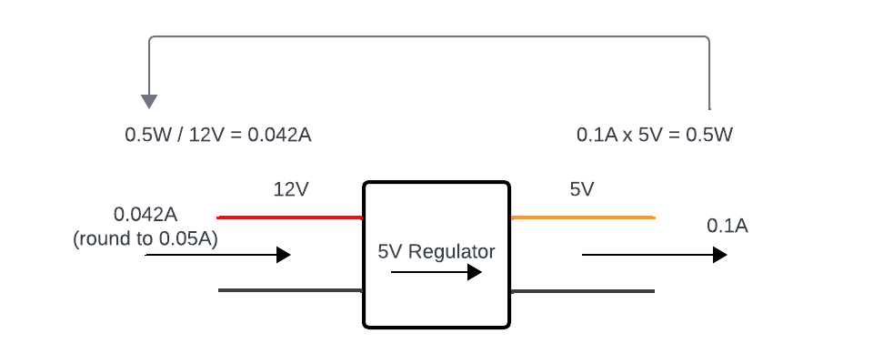

**Figure 2-4:** Finding the current into a voltage regulator

So, we know how much current our 5V components will draw- and we’ve appropriately chosen our 5V regulator- but how much current will our 12V components draw? We’ll need to know to choose an appropriate battery.

If we go back to our circuit diagram, we can see that our only 12V components are our motors. So how much current do our motors draw? We need to go back to the datasheets to find out. We’ll consider the worst-case scenario to be safe when selecting our battery specs, which will occur when the motors are stalled (set to their max-speed setting, but not moving because there is too much resistance). In the [motor data sheet](https://www.pololu.com/product-info-merged/5225), we can see the stall current is 0.75A, and we have two motors making for 1.5A total. The total current our battery will need to supply is the motor stall currents and the input current to the 5V regulator, making for 1.55A total.

**Choosing a Battery**

Alright, we need a battery that can supply 1.55A at 12V. LiPos are excellent at storing lots of energy in a small space and releasing that energy very quickly. These traits make LiPos great for robotics, but also dangerous. Here are a few safety points you should follow:

* Be careful not to let the battery charge get too low, which will deteriorate the battery and quickly make it unsafe to use. We’ll calculate the expected runtime of our robot later; pay attention to that runtime and if you notice your robot getting slower, the battery charge is dropping, and you should charge it/switch to a new battery.
* A puffy and/or squishy LiPo is unsafe to use. A damaged case is also unsafe; if a LiPo cell is exposed to the air it will combust and you may not be able to put it out. You don’t want to short out a LiPo battery, and you don’t want to puncture a LiPo battery. If you have any reason to doubt the safety of a LiPo battery, find a battery disposal bin or facility and safely dispose of the battery.
* When you charge a LiPo, use a proper LiPo charger (and read the instructions), in a fire-resistant area, and under supervision. Have a contingency plan (such as a fire blanket, sandbags, or a charging cart you can quickly roll out into a parking lot) in case it does catch fire.

LiPos are incredibly useful devices and though these warnings make them seem scary, they are safe to use when treated with respect. I don’t want to scare anyone, but I do want to impress upon you what that respect involves so you don’t have to learn the hard way.

With that hefty disclaimer out of the way, let's talk about LiPo specs. A LiPo will usually list 3 different specs:

* The S-number. This is the cell count of the LiPo. For instance, 1S is 1-cell, 2S is 2-cell, and so on. Because a LiPo cell is always ~4V (because chemistry), the cell count governs the battery voltage. We want 12V from our battery, so we’ll select a 3S battery.
* The capacity, in mAh (milliamp-hours). That unit, mAh, refers to how much current you could draw from the battery to fully drain it in an hour. For instance, you can draw 1.55A (1550 mA) from a 500 mAh battery for about 1/3 of an hour, or 20 minutes.
* Finally, a LiPo battery will list its discharge rating, or C-number. This is a bit of a strange unit, but you multiply the battery capacity by the C-number, and it gives you the maximum current that can be drawn from the battery. If we have a 500 mAh, 35C battery, the maximum current we can safely draw from it will be 17.5A (more than 10x what we need to power our rover circuit).

We can absolutely use a LiPo battery as we develop code and bench-test our robot in the following lessons, but we know from our calculations that our battery will drain after approximately 20 minutes of runtime. Because of this, it might be smarter to power our robot from lab power supply or wall power supply when we’re working on it. Figure out what tools you have at your disposal and choose the setup that works best for you.

**Other Considerations**

At this point, we’ve performed some solid power calculations and designed an effective power circuit for our robot. We’ll stick with this circuit for the purposes of our workshop, but in the future when you build robots there are a few other items you may want to consider for your power circuits to improve the usability and safety of your designs.

* **Wire Gauge.** All our components need to be able to support the voltages and currents flowing through our circuit, which we’ve discussed thoroughly. What we haven’t talked about though, is that all our wires and connectors need to be able to support the currents flowing through them as well. Many factors affect the max current a wire or connector should carry (for our purposes the *gauge*, or diameter of the wire, is one of the most important), but you can find [tables to help you select an appropriate wire gauge](https://www.powerstream.com/Wire_Size.htm).
* **Fuses.** A fuse is a component designed to break when a certain amount of current flows through it. When we’re dealing with LiPo batteries, shorts are quite dangerous and can quickly lead to fires that are very challenging to put out. A fuse can add a margin of safety. If we include a fuse immediately after the battery connector, when a short occurs it will burn out and prevent our battery from catching fire. This is a great idea for most robots. We can also use fuses to protect specific components from overcurrent, but that can get a bit cumbersome on a small robot and with the affordability of most of the components on our rover, it may be easier to just replace components.
* **Power Switches.** Certain LiPo connectors are difficult to unplug (intentionally so). It's a bit unwieldy to turn your robot off and on by plugging and unplugging the battery. A power switch is incredibly convenient when your robot decides it wants to run away, so it's a great idea to add a power switch to most robots. This also helps minimize the risk of shorts when plugging and unplugging your battery.

**Assembling the Circuit**

Before we start plugging components into our breadboard, there are a few things we need to assemble. The first of those things is the voltage regulator. The first thing you need to do is gather a LiPo battery connector (JST Plug) and four 10cm jumper cables. Trim the ends off each and strip off the insulation to reveal the wire underneath. Not all the LiPo connectors in the package are the same; pay attention to figure 2-5 and be careful to grab the right one!

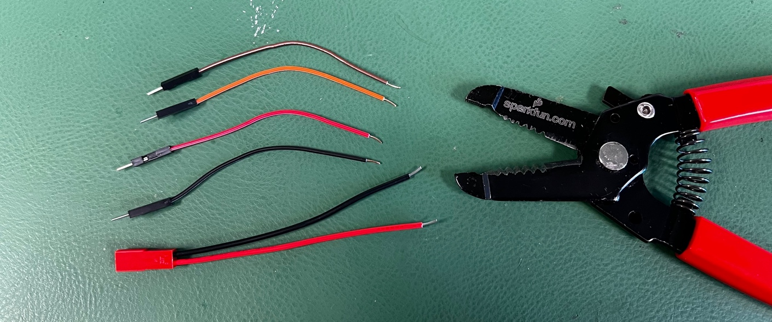

**Figure 2-5:** Trimming and stripping wires for the voltage regulator

Next, take two of the jumper cables and twist their wire ends together with those of the battery connector. Push those through the holes on the IN side of the voltage regulator (red goes to +, black to –) and solder them in place. On the OUT side of the regulator, attach and solder your remaining two jumper cables.

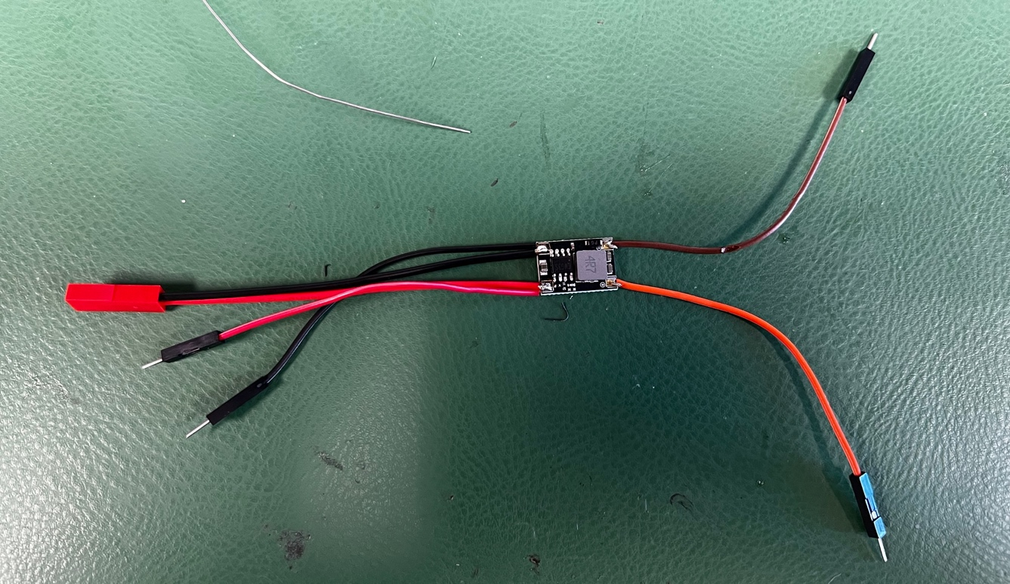

**Figure 2-6:** Assembled voltage regulator

For bonus points, twist the jumper cables together and heat shrink their ends to keep them tidy, then cover the voltage regulator with heat shrink to protect it and make it look nice. Aesthetics don’t necessarily imply function, but the people who take the time to make their work pretty are usually also the ones who take the time to do their work well.

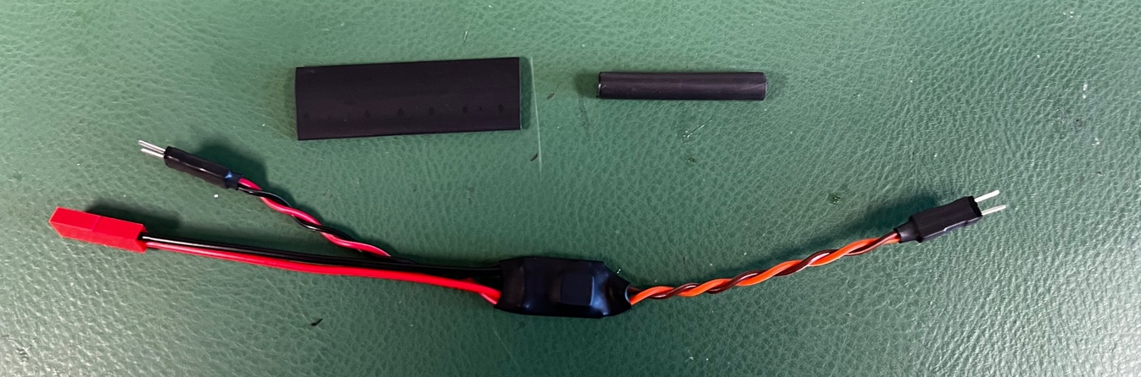

**Figure 2-7:** Voltage regulator dressed up all nice and pretty

The next component we need to assemble is much less intensive. We need to solder header pins onto the motor driver board. The best way to do that is simply to press the header pins into a breadboard and then place the motor driver on them. Solder all the pins, and when you remove the driver from the breadboard, the pins should be perfectly aligned.

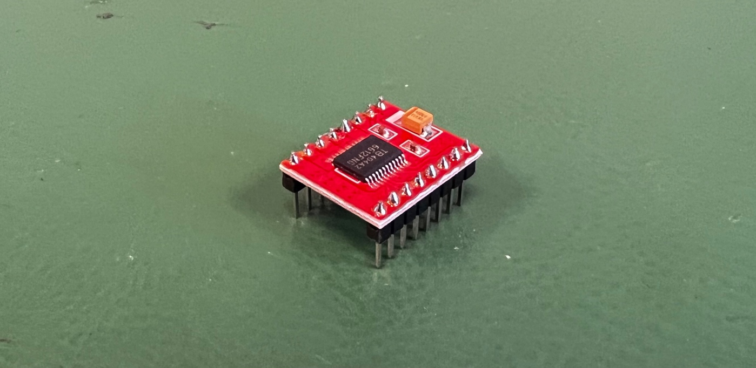

**Figure 2-8:** The assembled motor driver

Place the motor driver on the breadboard with the largest chip on the board toward the front of the rover. Press the left row of pins into D6-D13 and the right row of pins into H6-H13. You may need to remove the left motor cable connector briefly to do this.

Then, plug the jumper cables at the output of the voltage regulator into the right power rails of the breadboard. This set of power rails is now your 5V bus. Plug the jumper cables at the input of the voltage regulator into the left power rails of the breadboard. These power rails are now your 12V bus. If you’re unfamiliar with breadboards and want to understand what these terms mean, [here’s a guide](https://www.sciencebuddies.org/science-fair-projects/references/how-to-use-a-breadboard).

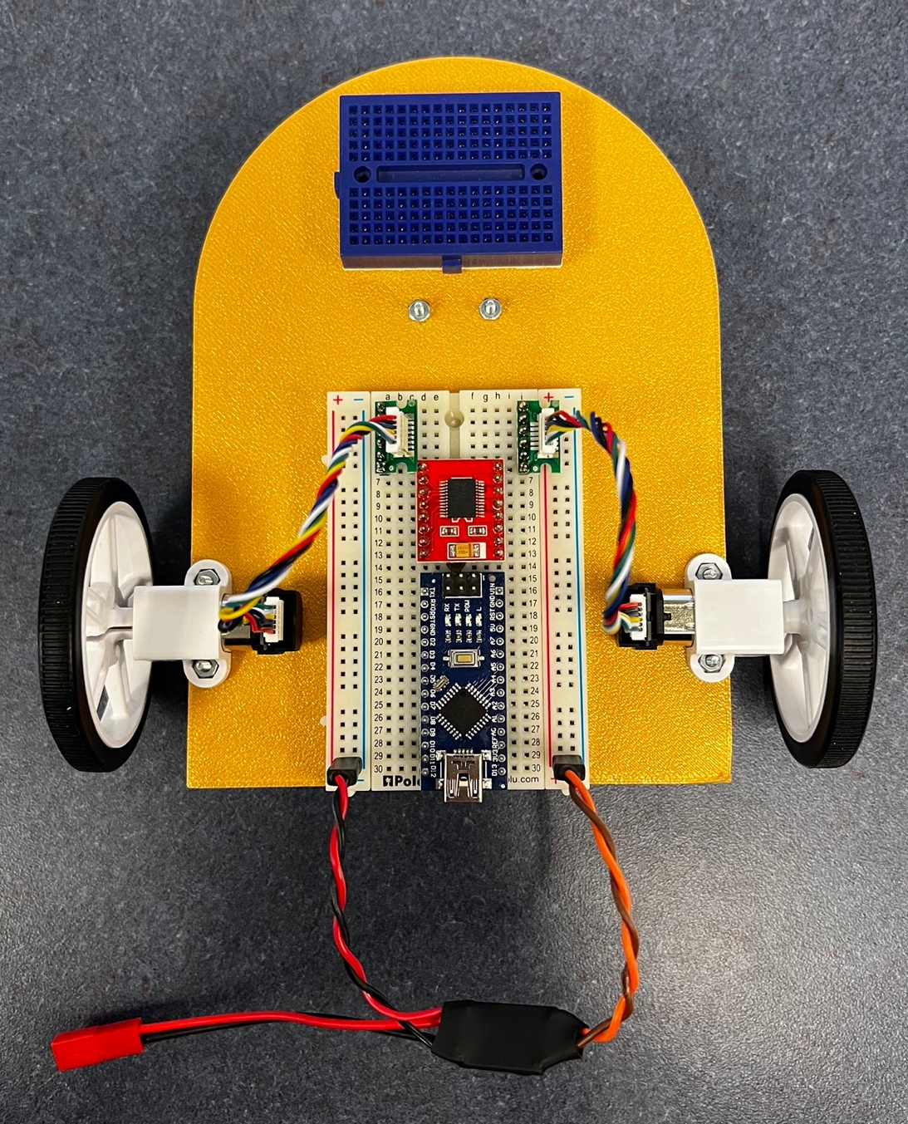

**Figure 2-9:** The motor driver and 5V regulator properly placed on the breadboard

The last thing we need to do is make the necessary connections to get 12V and 5V power to the places they need to go. Both the Arduino and motor driver need 5V power. Use jumper cables to connect the VIN and VCC pins (J16 and J12) on the Arduino and driver to the 5V rail (right+) and the GND pins (J17 and J11) on the Arduino and driver to the ground rail (right–). The motor driver also has a pin called STBY. Unless this pin is raised to 5V, the motor driver won’t work, so plug this (A10) into 5V too.

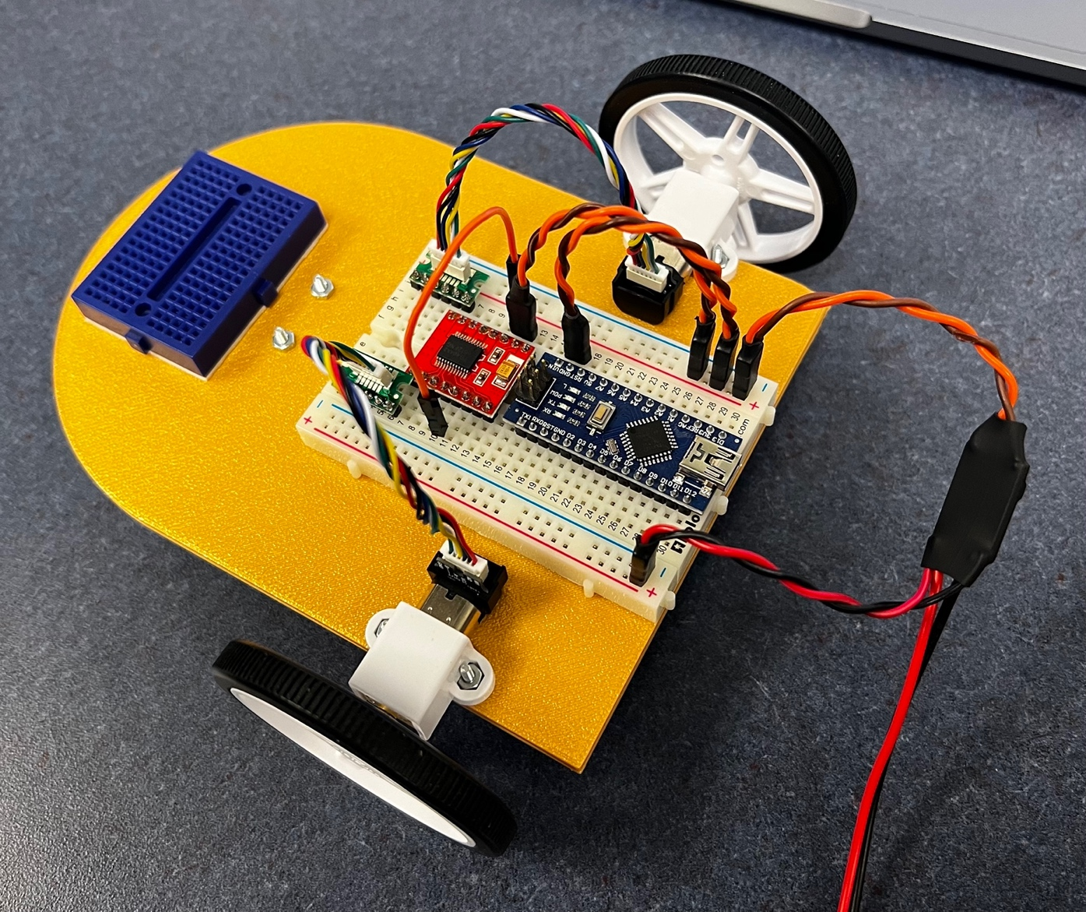

**Figure 2-10:** 5V connections (orange/brown wires) made on the breadboard

Remember from Figure 2-3 that our motors are the only 12V components we have, but they get 12V through the motor controller. Even though the motor controller itself doesn’t run on 12V, the VM pin on the motor controller is designed to accept 12V and feed it to the motors through some circuits we’ll learn about in the next lesson. To supply the motor driver with 12V, take a jumper wire from the 12V rail (left+) and plug it into J13. There isn’t any need to make a ground connection– doing so wouldn’t cause any problems, but a common ground between the 12V and 5V buses is already provided by the 5V regulator, so the motor driver is properly connected to ground.

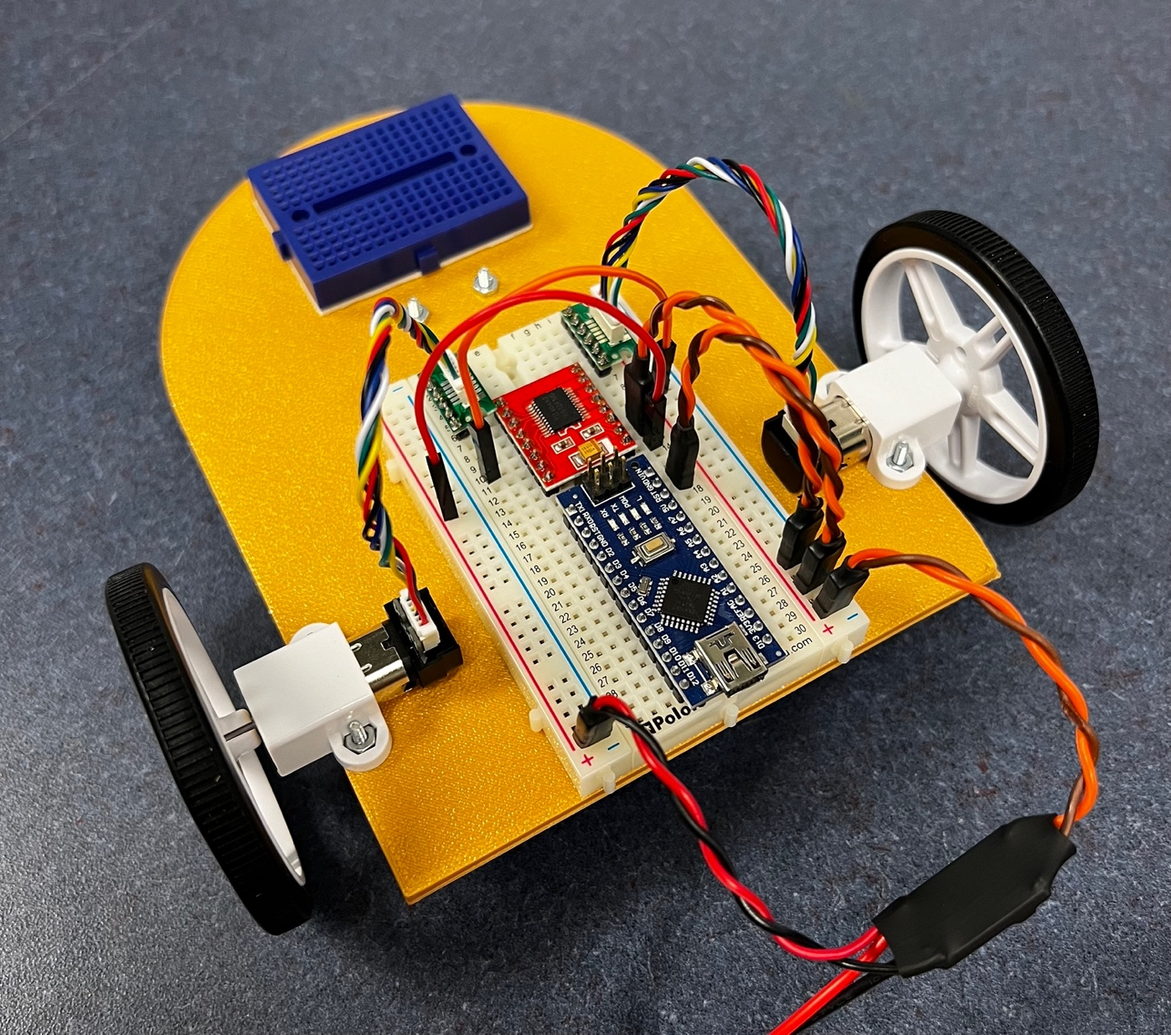

**Figure 2-11:** 12V connection (red wire) between the 12V bus and motor driver

The last connections we’ll make are between the motor driver and the motors. On the motor driver there are pins labeled AO1/AO2 and BO1/BO2. These are the output pins of the motor driver which send power to the motors. The first step is to take 1 red jumper wire and 1 black jumper wire for each motor. Twist the first red/black pair together and plug the red into E1 and I8 and the black into E2 and I7 to connect the left motor to the driver. Twist the second pair together and plug the red into F1 and I10 and the black into F2 and I9 to connect the right motor.

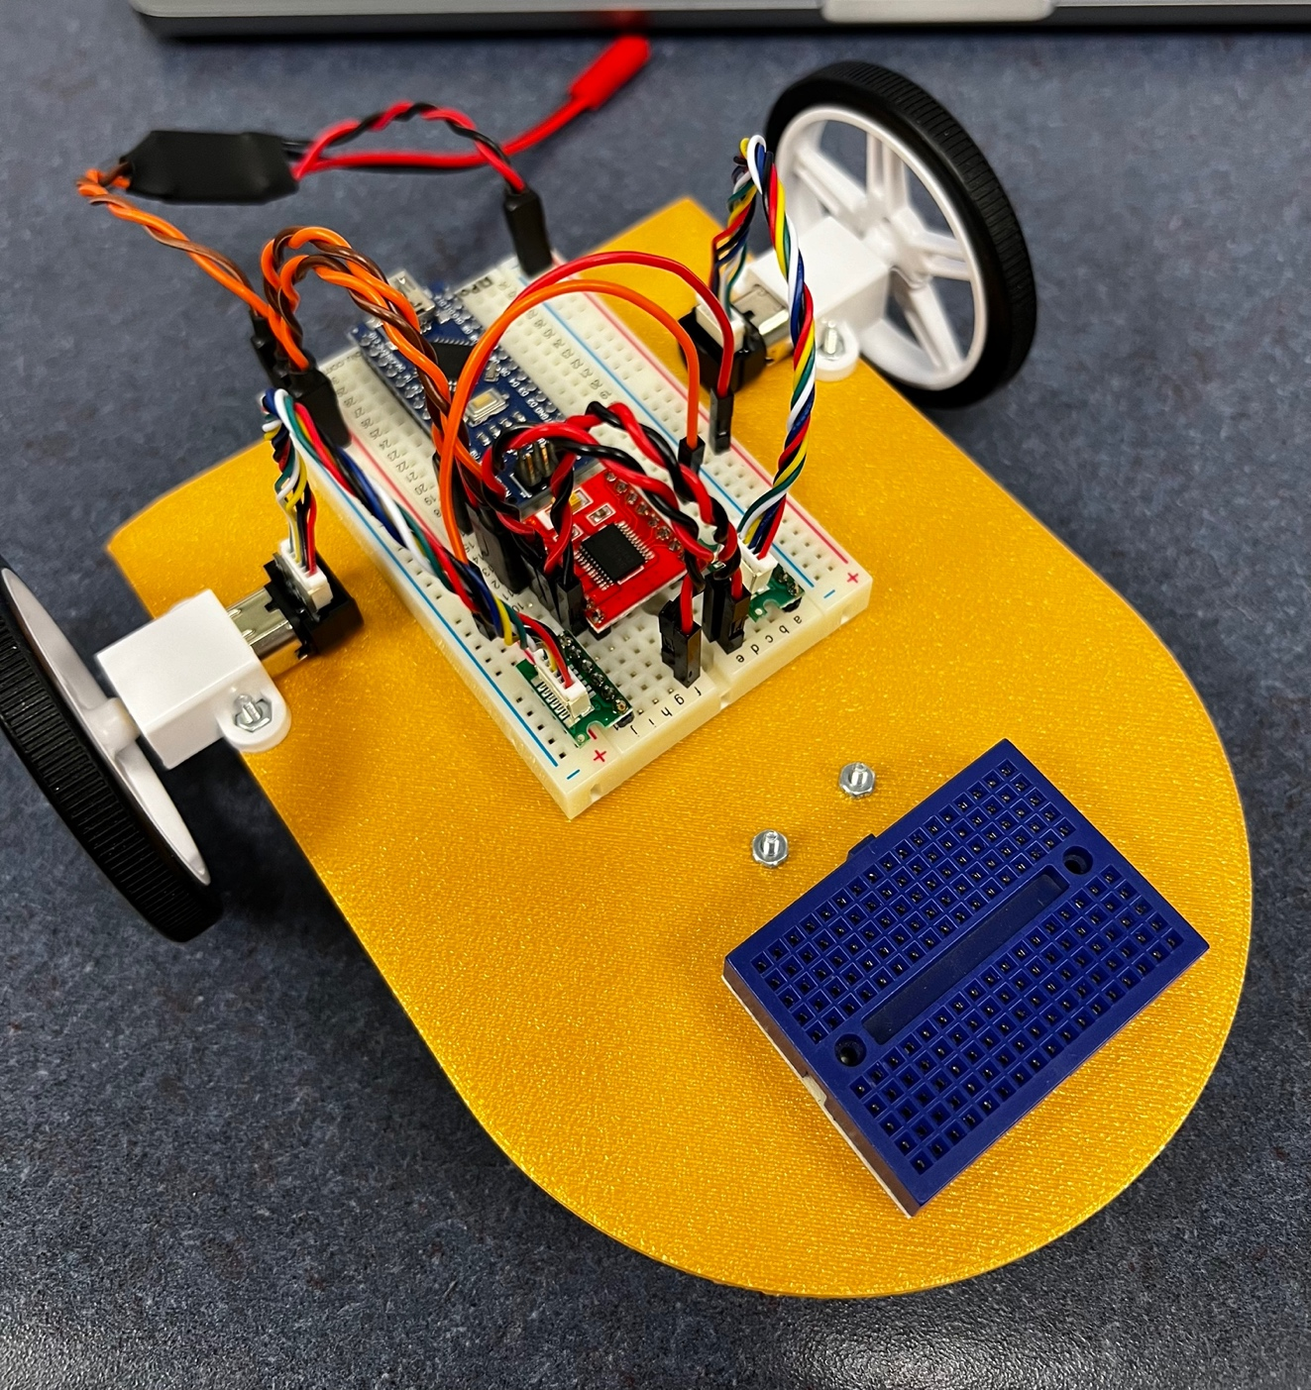

**Figure 2-12:** Motors connected (twisted red/black wires) to motor driver

That completes the robot’s power circuit! In the next lesson we’ll finally get around to making our rover move.