Lesson 1 – Building a Rover
In this lesson we’ll be looking at the conceptual design of our rover, different types of rover drive systems, and the components that make up a rover. We’ll briefly discuss some options for designing and manufacturing our rover chassis, and by the end of this lesson we’ll have an assembled rover ready to accept our electronics. Be sure to check out the Robotics Workshop discussion page if you find yourself needing help!
Differential Drive Robots
The rover we’ll build for this workshop is a differential drive robot (a rover can be a type of robot; we’ll use the terms interchangeably), which means the robot has two driven wheels- one on the left, and one on the right. These two driven wheels control all motion, and any other wheels on the robot are there only to keep the robot stable and minimize friction (these extra wheels are usually called caster wheels). This drive system is simple and nimble since it can turn on a dime (called a zero-point turn) and will work great on flat and level surfaces while we explore other robotics concepts. In more challenging terrain, though, you may want to explore more complex drive systems that can offer better traction and stability.
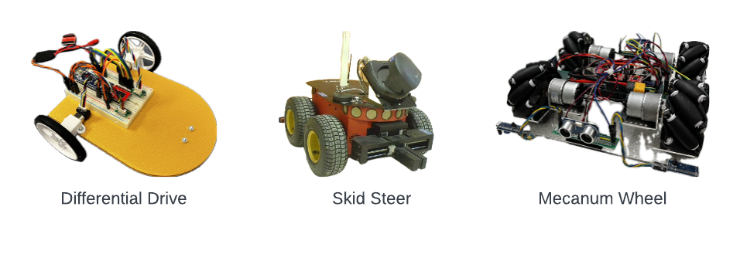
Figure 1-1: Examples of different robot drive systems
Later, we’ll want to precisely control how our robot moves and (for certain tasks) keep track of its position in the world. To do that, we need to understand how moving the wheels of our robot in a certain way will cause our robot’s body to move. For that, let's consider a robot driving along a windy path (the dashed line). At some point on the journey, you come along and take a picture of the robot from above. The robot, at that instant, has a forward velocity v and angular velocity w. A differential drive robot can move in two ways: it can move forward and backward, and it can spin left and right. That means it has two degrees-of-freedom, and we can represent the robot velocity with a linear component and an angular component.

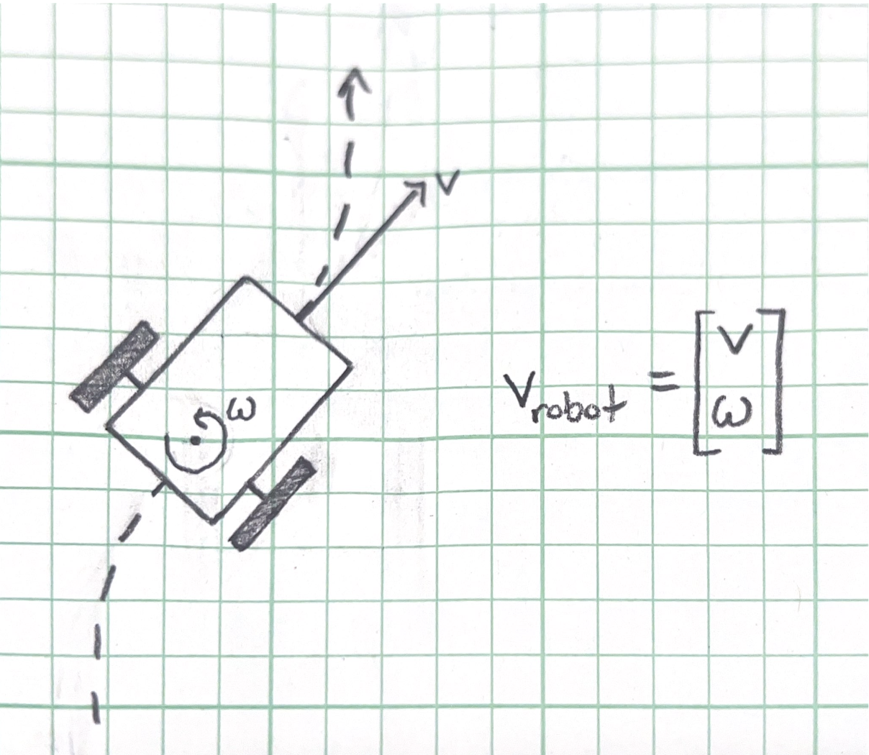
Figure 1-2: Robot driving along a winding path
So, our robot’s velocity at any instant can be described with a linear velocity v and an angular velocity w. That’s simple enough, but what we really want to know is how those two quantities relate to the speeds of the left and right wheels. Now let's consider a single wheel, rolling along the ground. The radius of the wheel is r, the angle it has turned (in radians) is ø (phi), and the linear velocity of the center of the wheel is v_wheel.
The relationship between angular velocity and speed tells us that v = r x w, where w is angular velocity. Phi* (pronounced “phi dot”) means “the derivative of angular position”, which is equivalent to angular velocity. It’s easy to confuse the angular velocity of the wheels with the angular velocity of the robot body (which we’ll expand on in a moment), so for now we’ll use phi* for the former and w for the latter.
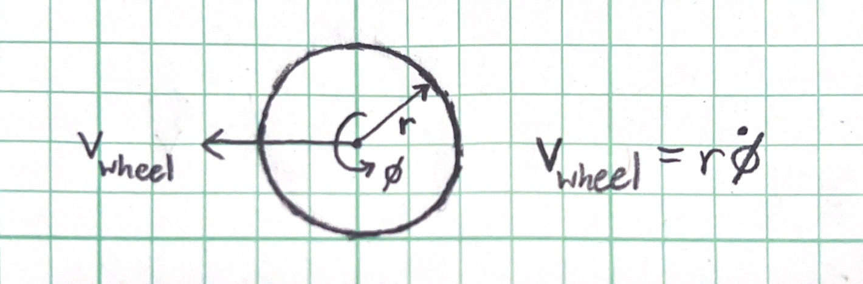
Figure 1-3: The relationship between angular velocity and speed of a wheel
We have almost all the puzzle pieces. But our wheels don’t exist in isolation, they’re attached to a body that ties them together. Let's think about two special cases to understand how that affects things. In the first, both wheels turn in the same direction, causing the robot to go straight forward. In the second, both wheels turn in the opposite direction, causing the robot to spin in place.
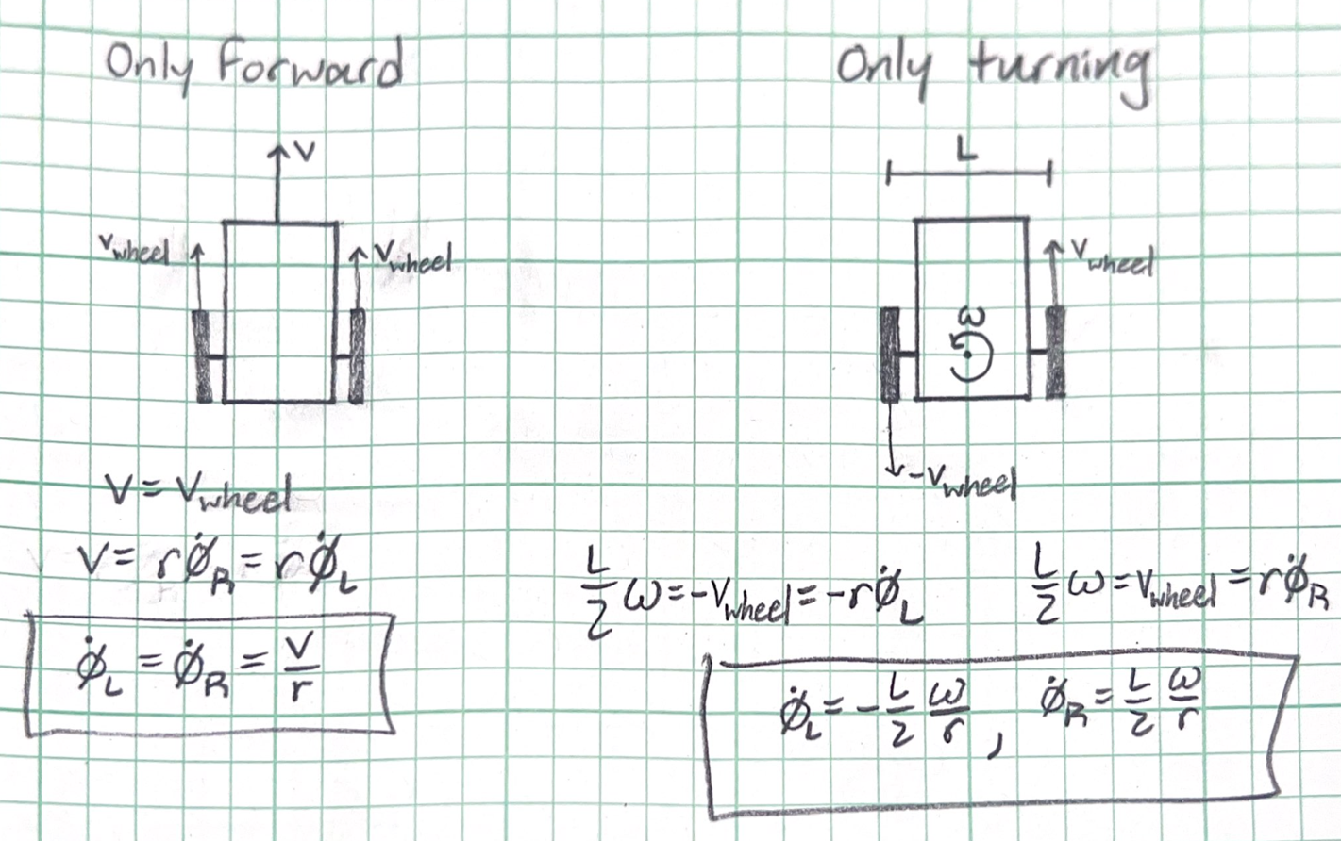
Figure 1-4: Special cases for a differential drive robot
Finally, by adding the equations resulting from the “only forward” and “only turning” cases, we get the inverse kinematics equations for our differential drive robot:
$\dot{∅_{L}}=\frac{v}{r}-\frac{L}{2}\frac{ω}{r}$ $\dot{∅_{R}}=\frac{v}{r}+\frac{L}{2}\frac{ω}{r}$
These two equations describe the inverse kinematics of our bot because given a desired output v and w, they find the required inputs phi*_L and phi*_R (angular velocities of the left and right wheels). With some algebra, we can convert these to our forward kinematics equations, which get us the output velocities that would result from a set of input wheel speeds:
$v=\frac{r}{2}\left(\dot{∅_{R}}+\dot{∅_{L}}\right)$ $ω=\frac{r}{L}\left(\dot{∅_{R}}-\dot{∅_{L}}\right)$
For those of you who followed along and feel comfortable with this discussion of differential drive kinematics, great work! For those of you who feel confused, that's okay. This is complicated material and though we’ll revisit it later, you don’t need to understand it to complete these lessons.
Rover Components
Our rover needs to do a few things. Most critically it needs to move, and it needs to stay in one piece. By selecting a differential drive system, we’ve already described how we want our rover to move: with two driven wheels that control both linear and angular motion. If we have two driven wheels, then we’re going to need two motors to drive them. We need a caster wheel for the robot to balance on and a chassis of some sort to rigidly connect these parts. Finally, we’ll need screws to fasten everything together. Altogether, that gives us roughly this parts list here:
- 2x Wheels
- 2x 12V DC Motors
- 2x Motor Brackets
- 1x Caster Wheel
- 6x #2-56 Screws
- 6x #2-56 Nuts
- Breadboards
- 2x Motor Cables
- 2x Motor Cable Connectors
- Chassis...
The only part we don’t have from our kit is the chassis (pronounced “CHASS-ee”). That's no problem; we can create our own chassis using a CAD program and rapid prototyping tools.
Creating a Chassis
A great CAD tool for designing your robot is Onshape. It’s free for students and hobbyists and isn’t picky about operating systems, so we’ll be using it for the workshop. Go ahead and create an Onshape account if you don’t have one.
We won’t be diving into how to design parts in Onshape right now. Creating parts and assemblies in a CAD program is a bit too big of a topic for a robotics tutorial, but if you want to dive into the great big world of CAD, it's a very useful skill and you can find Onshape tutorials here. Instead, we’re going to talk about how to manufacture parts designed in CAD.
Once you’re in Onshape, go to the search bar and type in “COSGC Robotics Workshop Rover Chassis”. Right click on the document that comes up and hit “copy workspace”.
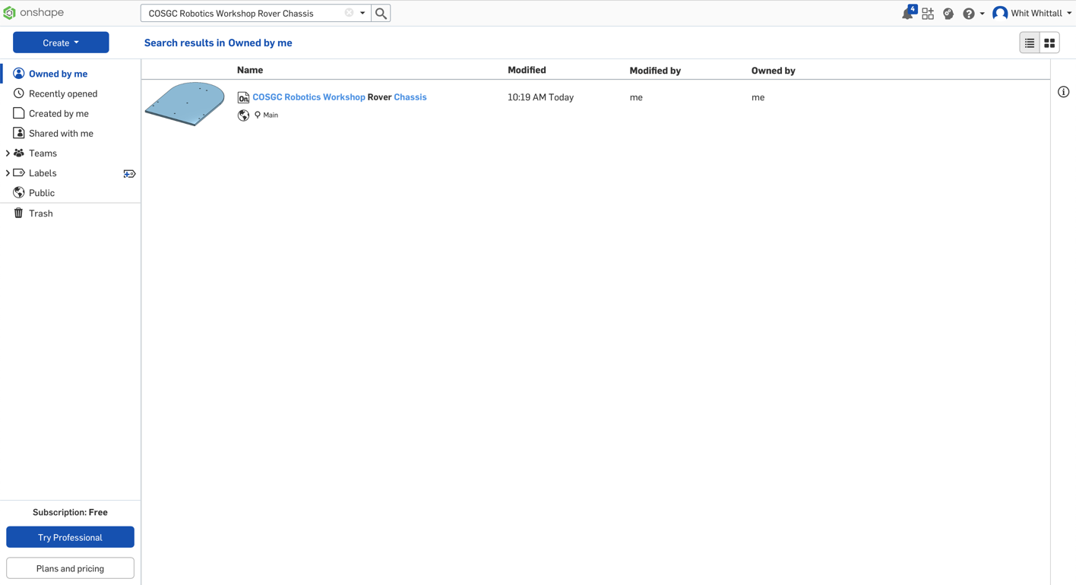
Figure 1-5: The Onshape search screen
Open the workspace you just created. You should see 7 tabs along the bottom of the page, with the first two labelled “Rover Chassis” and “Rover Assembly”. Click on these tabs (and any others you want to check out) to explore the rover design.
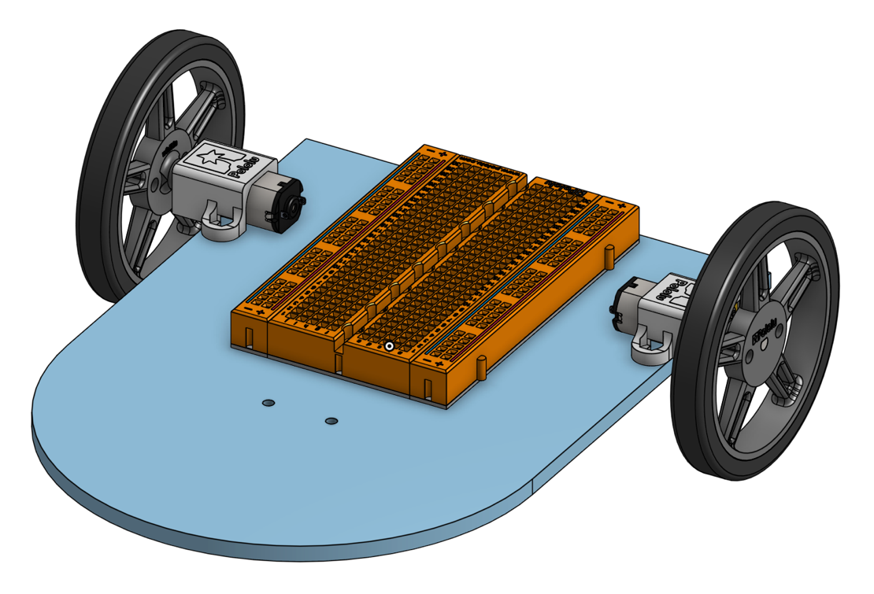
Figure 1-6: 3D model of the workshop rover
A rover chassis doesn’t need to be complicated. In this case, it’s just a flat plate with holes in it so we can use bolts to fasten parts to the chassis. This part lends itself well to laser cutting, so we’ll discuss that first.
Laser cutting is a manufacturing process where a tool head equipped with a high energy laser is used to melt through a material. By moving the tool head along a pre-defined path, we can cut out incredibly complex 2D parts. Laser cutting can’t produce 3D part features and comes with some limitations on material types and thicknesses we can use, but for 2D parts like our chassis laser cutting is quick and produces high-quality results.
Usually, laser cutting begins with a DXF file. To export a DXF file from Onshape, right click on Sketch 1 in the “Rover Chassis” tab and select “Export as DXF/DWG”. Click “Export” in the resulting popup menu and save the file to your computer.
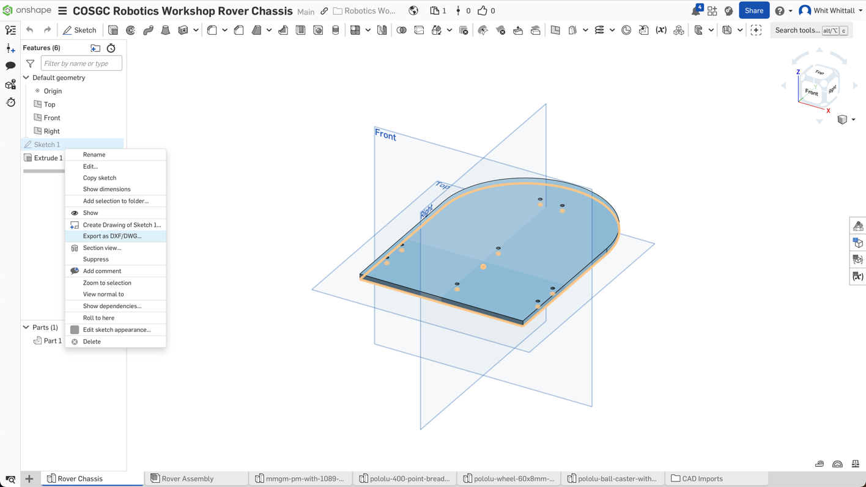
Figure 1-7: Exporting a DXF file from Onshape
At this point, you’ll usually need to upload your DXF file into a vector graphics editor such as CorelDRAW on a computer connected to the laser cutter, set the cut settings, and let it run. If you have access to a laser cutter but aren’t yet familiar with how to use it, find someone knowledgeable to walk you through the process.
If you don’t have a laser cutter, there are other options for creating your chassis. These days, 3D printers are extremely common at schools, public libraries, and even among hobbyists who buy them for home use. Making a part on a 3D printer from a model in Onshape is pretty simple. In the “Rover Chassis” tab, right click on Part 1 and select the “Export” option.
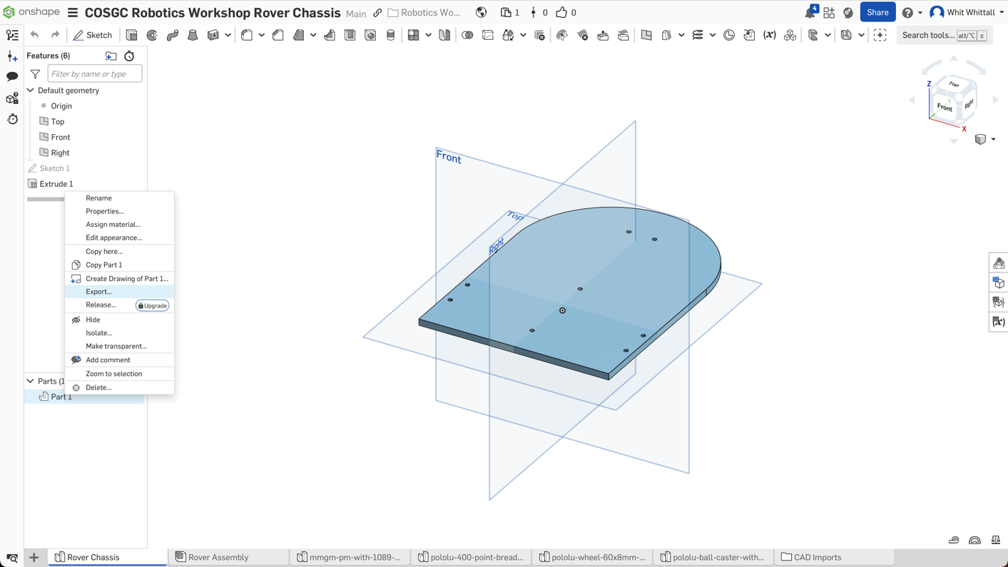
Figure 1-8: Exporting an STL file from Onshape
Onshape will bring up a popup menu just like before. Make sure to select “STL” under “Format”, then click “Export” to continue.
To 3D print, you need a program called a “slicer” that creates a toolpath for the printer to follow from a .stl file. Slicers can look intimidating but are usually easy to use. If you are unfamiliar with 3D printing, find someone knowledgeable to help you import your .stl file into the slicer, prepare it for printing, and then print the part.

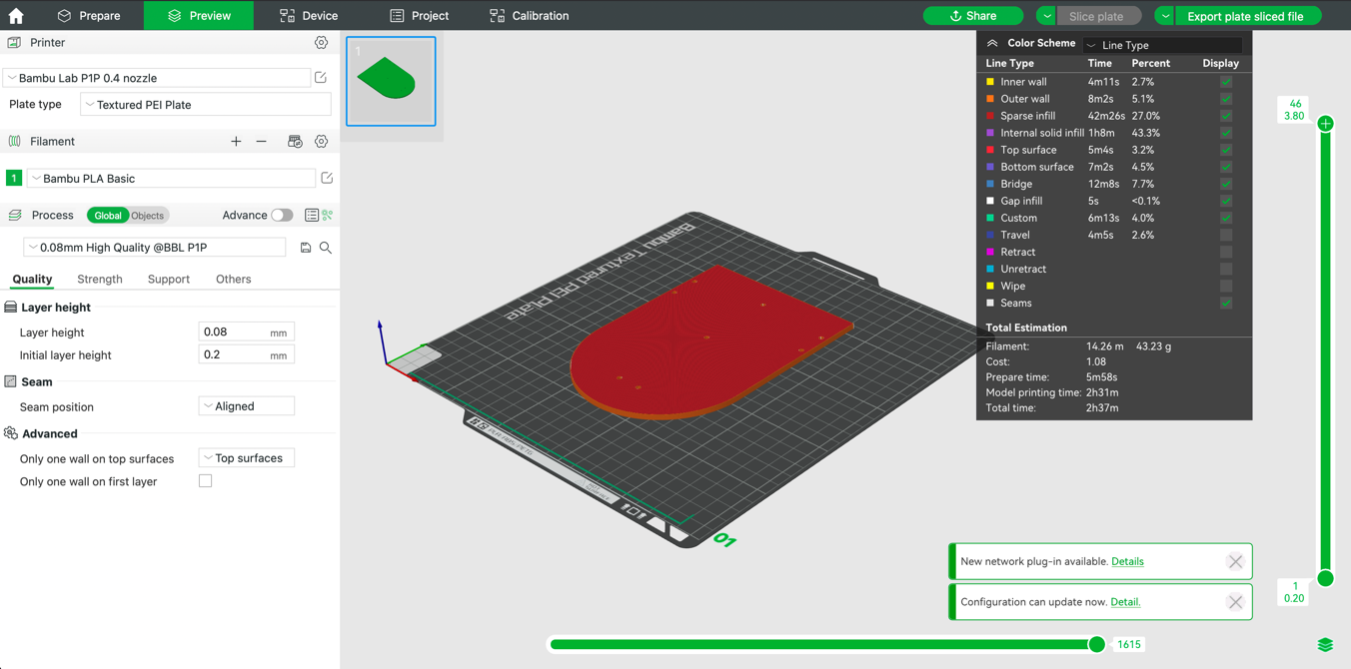
Figure 1-9: An example of a slicer program
Regardless of how you make the chassis, all it must do is rigidly connect each component to one another. If you don’t have access to a laser cutter or 3D printer, there are other ways to make a chassis. You can even make one with some thin plywood or balsa and a drill if you want.
Assembling the Rover
We now have all the parts needed to build the rover, including our chassis. Time to put it all together. The first step is to slide the wheels onto the motor axles. Notice the motor axles are D-shaped; they have a flat side. Make sure you line this flat side of the axle up with the flat side of the axle hole in the wheel when you slide the wheel on. This prevents the wheel from slipping when the motor turns. Be careful as you slide the motor axle into the wheel, be gentle with the motor so you don’t damage it. It helps to use a flathead screwdriver to pry the axle hole open, so you don’t need to press hard on the motor.
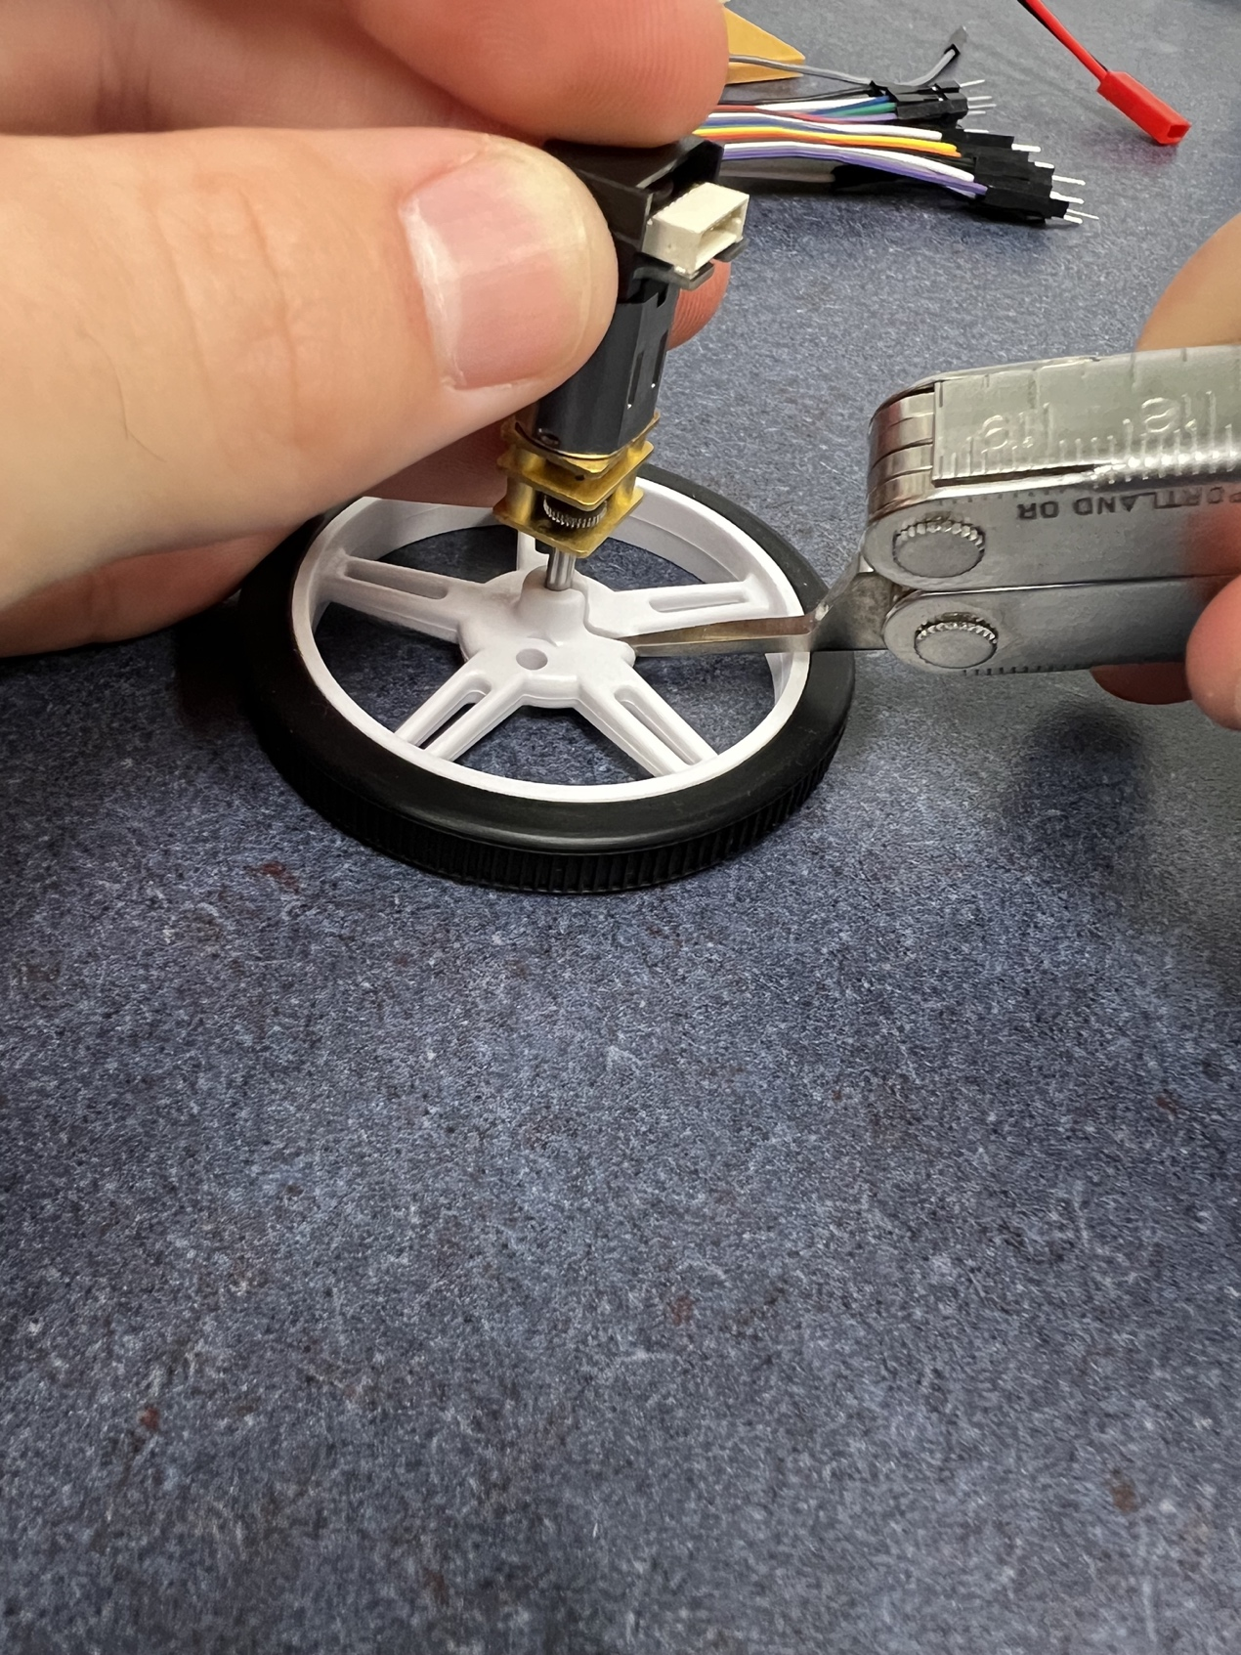
Figure 1-10: Use a flathead screwdriver to make sliding the wheels on easier
Next, use the motor brackets, 4 bolts, and 4 nuts to mount the motors to the chassis. Pay close attention to figure 1-11. If the gearbox extends out past the white motor mounts, you’ve mounted your motors improperly. Mounting the motors incorrectly will affect the performance of your rover down the road (the distance between the wheels is an important parameter in the rover’s kinematic equations)!
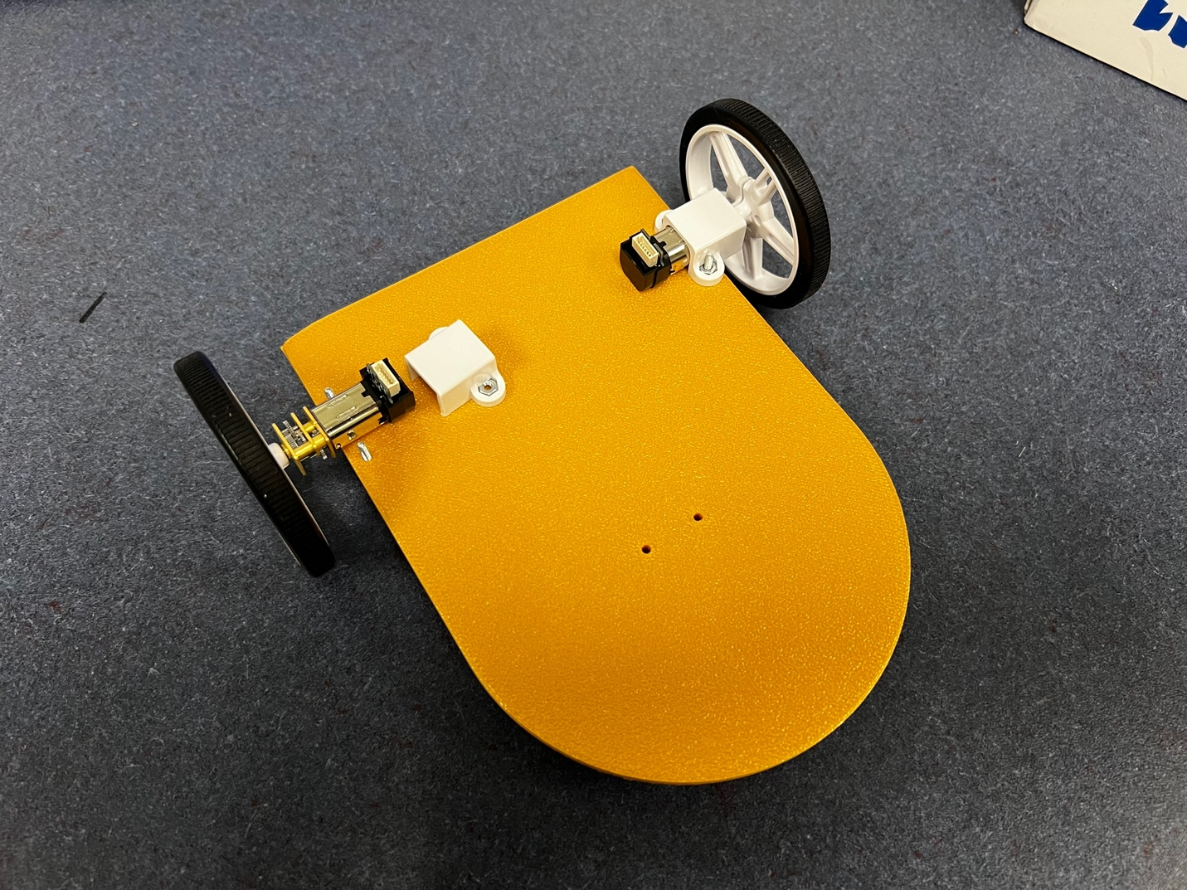
Figure 1-11: Mounting the motors to the chassis
The black caster wheel housing is attached to the underside of the chassis in a similar way. Place 2 bolts through the holes in the housing, then press those bolts through the holes near the front of the chassis. Place nuts onto both of those bolts and tighten them. You may need a pair of pliers to hold the nuts still while you tighten the bolts. Only once the bolts are tight enough they won’t come loose can you press the metal caster ball into the housing.
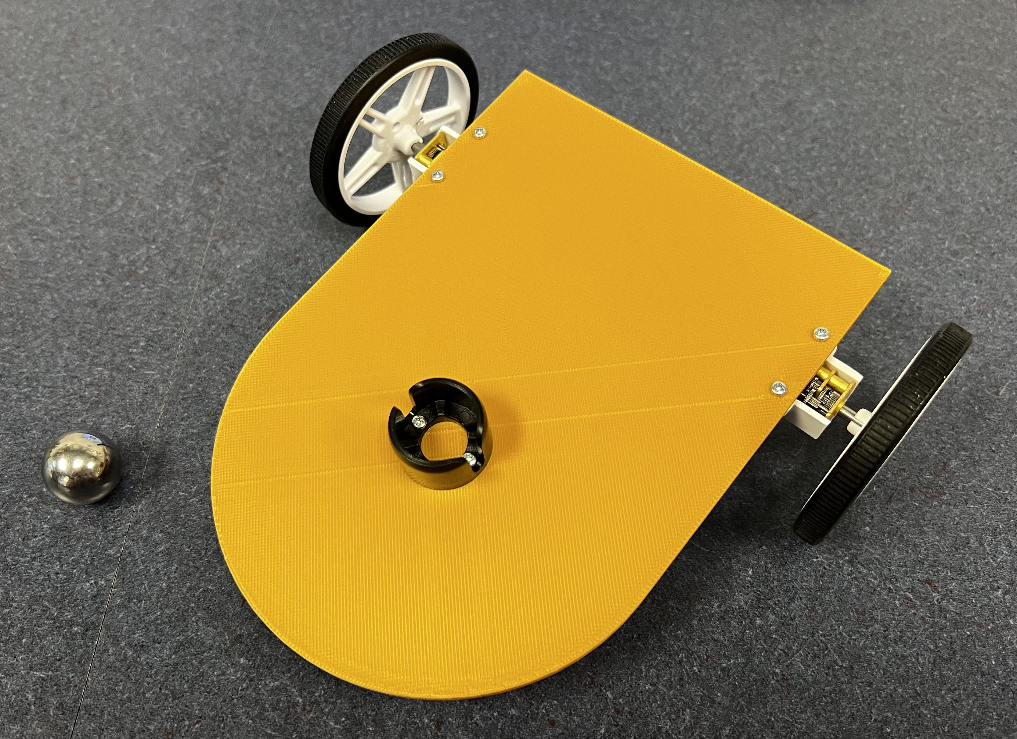
Figure 1-12: Caster housing attached to the chassis; next insert the caster ball (shown left of the chassis)
Next, we’re going to stick down the breadboards. The underside of the breadboards has a sheet of yellow sticker paper on them; peel that up to stick them down like stickers. Press the large breadboard down along the back edge of the chassis, centered between the motors. The small breadboard goes up at the front, just in front of the caster wheel bolts.
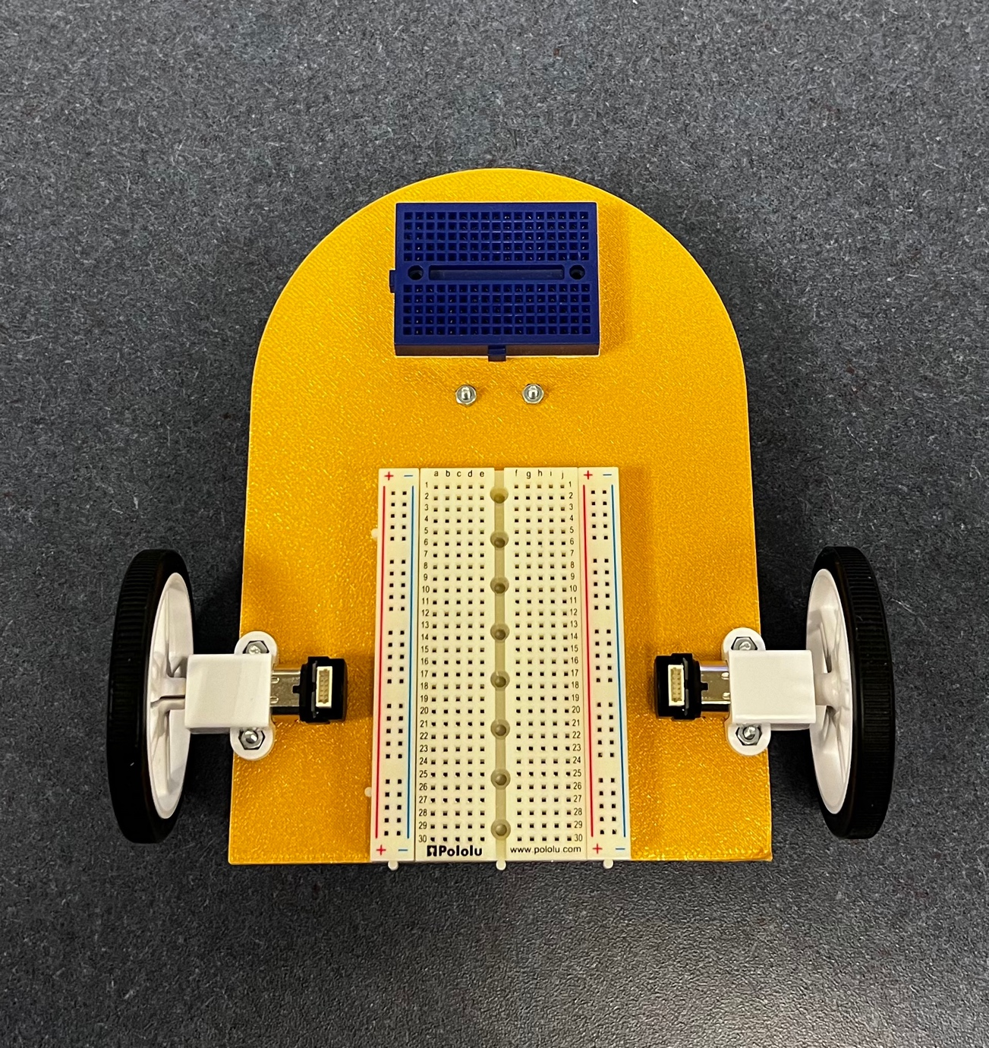
Figure 1-13: Proper location and orientation of the breadboards
Now let's solder the motor cable connectors. First, snap off 6 header pins for each connector. The easiest way to solder these header pins is to stick the pins into a breadboard and solder just one of the pins to the connector. When you first make this joint, the connector will “droop” down. To fix this, place the iron back on the joint you just made to reheat the solder. Use your free hand to correct this droop, then remove the iron. Wait for the solder to cool before you remove your hand. Finally, solder the rest of the pins to the connector. Repeat this process for the second connector.

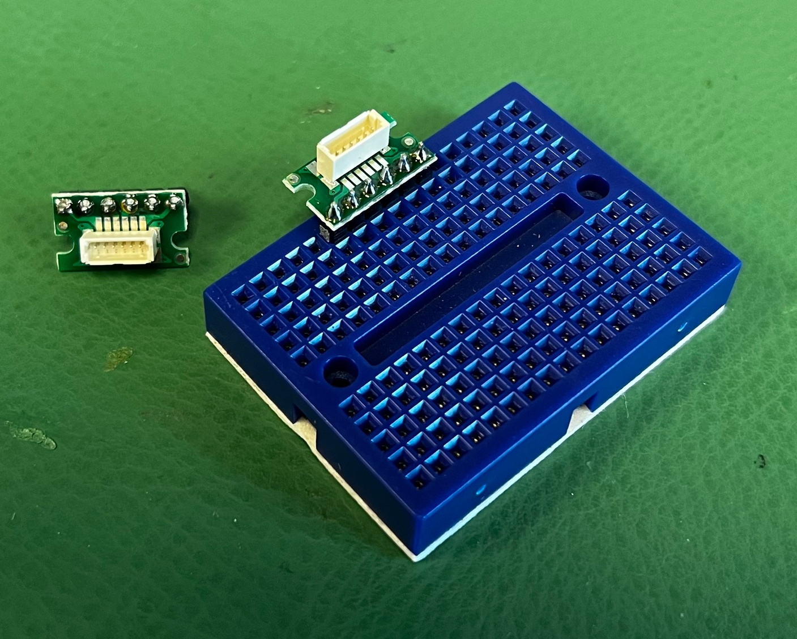
Figure 1-14: Using a breadboard to help solder the motor cable connectors
Now we’ll place our first components on the breadboard. Plug the motor cables into the motors and the motor connectors. Don’t force the plugs into either of these; look closely and you’ll see the plugs are meant to insert in a specific direction. Next press the left motor connector into A1-A6 and the right connector into J1-J6 on the large breadboard. Make sure the red wire of each of the motor cables are facing forward.
Last, get your Arduino Nano. If the header pins are not already soldered on, take the time to do so. Then we’ll place the Arduino on the large breadboard. It's important that you place the Arduino on the breadboard such that the USB connector is towards the back of the rover. Press the left row of pins on the Arduino into D16-D30 and the right row of pins into H16-H30.
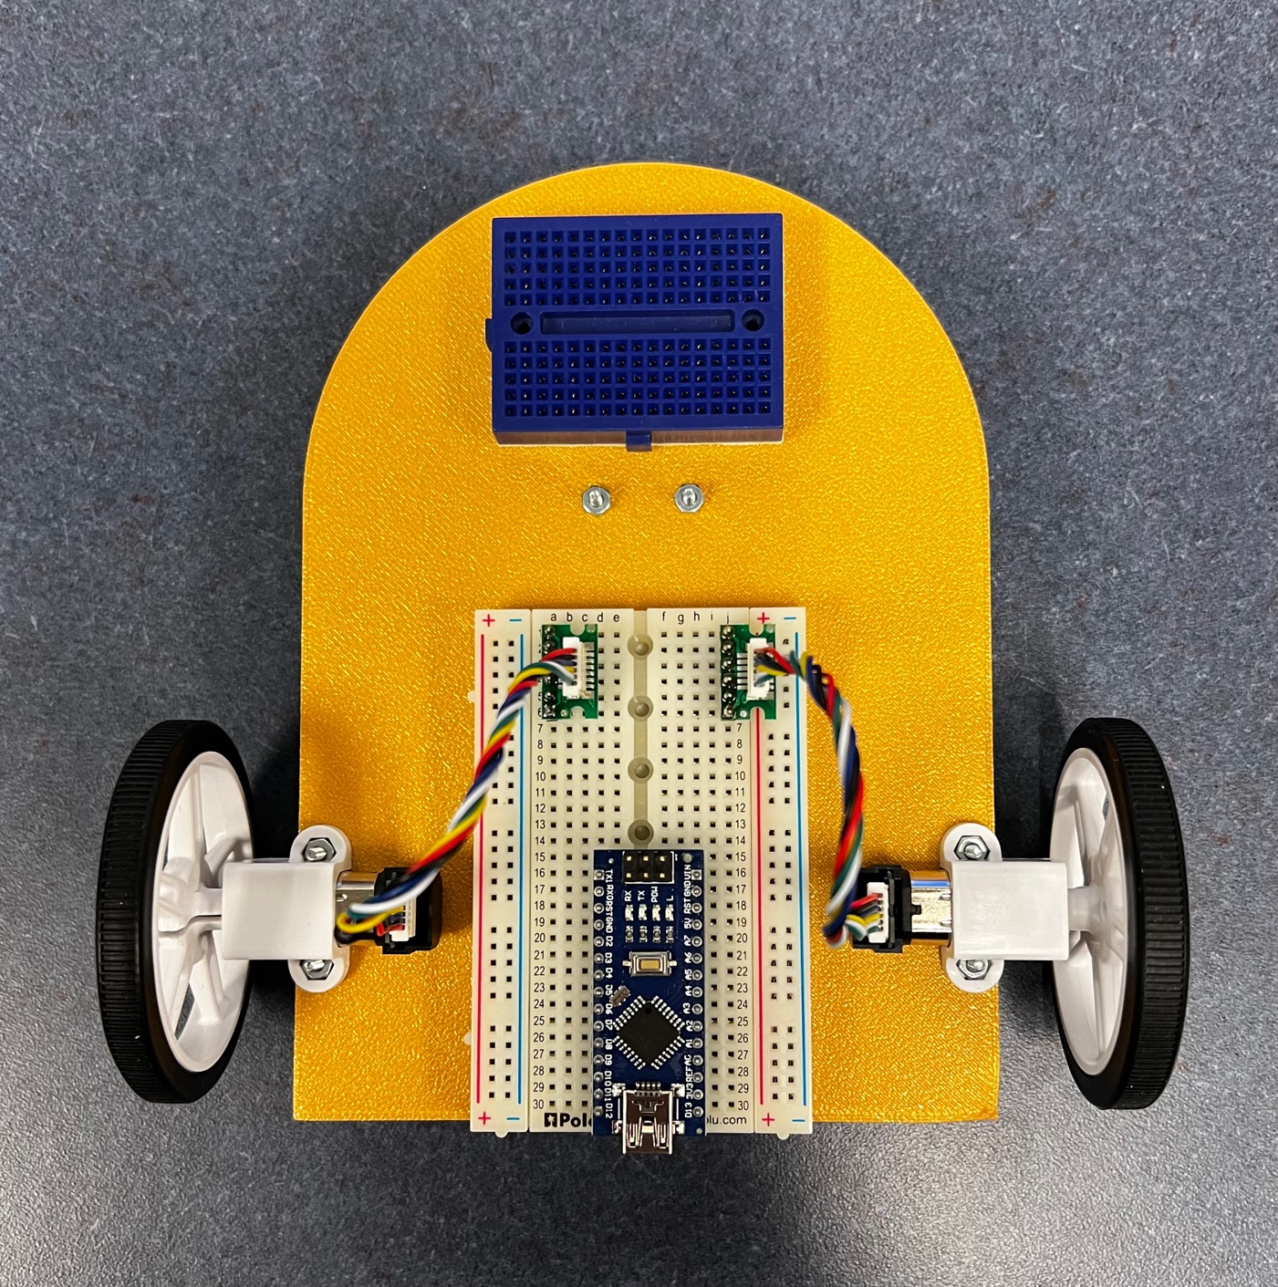
Figure 1-15: Proper placement of the cable connectors and Arduino on the breadboard
Congratulations! We’ve covered a lot of material in this lesson, and in the next lessons we’ll use the platform we built today to learn about robot circuitry and motion. Before long, your rover will be roving all over the place.

