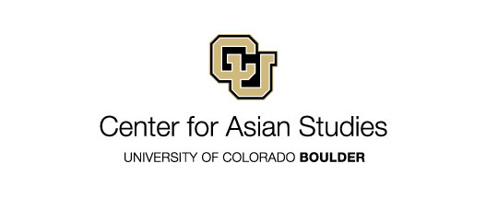
Application for Tibet and Himalayan Studies Professional Development Grants

Funding Details
Application Deadline: Monday, May 16, 2022
Funding provided by: CAS US Department of Education UISFL Grant
Amount: $1,500 each (two awards available); to be paid as summer salary or as reimbursement for travel or course materials in Summer 2022.
Instructions
To apply, please fill out this form, and submit it, along with applicable attachments, electronically to cas@colorado.edu. Questions may be directed to CAS Executive Director Danielle Rocheleau Salaz (salaz@colorado.edu).

Application Submission Date: _______________________

Applicant Information
1. Name and Title:
2. Department or Affiliation:
3. Campus Box #:
4. Telephone:
5. Email address:
6. Name and Email Addresses of Department Chair and Administrator:

Course Information:

1. Description of course to be developed or revised.

2. Potential role of the course in CU curriculum (in the spirit of a university course proposal).

3. List of other courses taught by applicant.

4. If applying for funds for materials or travel: Brief budget detailing expenses the funds would cover (not to exceed $1,500). Also include travel dates—funding for international travel requires 30 days for preapproval from the US Department of Education and compliance with the Fly America Act.

5. If applying for summer salary: Do you plan to teach over the summer? Note: If you opt to take summer salary, it will be subject to taxes and withholding.

Please also submit the following attachments:

1. CV

2. Copy of previous syllabus (if proposing a course revision).

Note: Award recipients will be asked to submit a report and syllabus for the new course during the Fall 2022 semester. New or revised courses should be considered for cross-listing with Asian Studies. Failure to meet these conditions will result in ineligibility for future CAS faculty awards.

