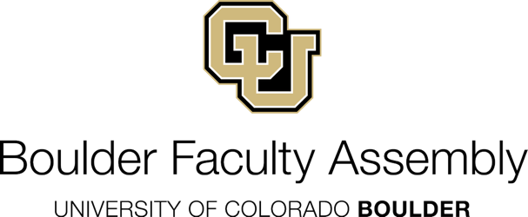

CU Boulder Faculty Assembly Organization Chart

Boulder Faculty Assembly
BFA Chair
BFA Chair-Elect
BFA Immediate Past Chair
BFA Parliamentarian
UCB Shared Faculty Governance Advisor

BFA Executive Committee

BFA General Assembly

BFA Standing Committees
Academic Affairs AAC
Academic Technologies ATC
Administrator Appraisal AAPC
Budget & Planning BPC
Bylaws & Elections BLWS
Campus Operations & Resources CORC
Climate Science & Education CSEC
Faculty Affairs FAC
Diversity, Equity, Inclusion DEIC
Grievance Advisory GAC
Intercollegiate Athletics IAC
Student Affairs SAC
Teaching Faculty Affairs TFAC
Libraries, Academic Materials, and Publication LAMP

BFA Coordinator
Kelly Curtis

