Directions for Using DocuSign Course Banking Template

- Log in to DocuSign at https://account.docusign.com/#/username using your IDENTIKEY@Colorado.edu email address
- For questions regarding DocuSign access, please contact help@colorado.edu. Please specify you are requesting access to the Arts and Sciences offer letter templates.
- Click on “Templates” at the top of the screen.
- Click on “Shared with Me” from the list on the left side of the screen.
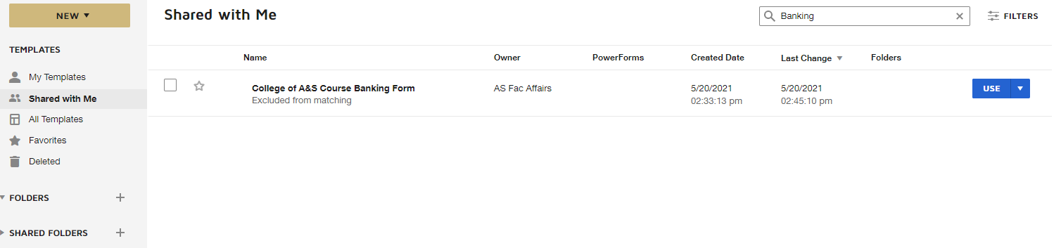
- Find “College of A&S Course Banking Form” from the list of templates. The owner is AS Fac Affairs.
- Click the drop down arrow to the right of “use” on the line with the template, then click “Copy.” Do not simply click “Use.”
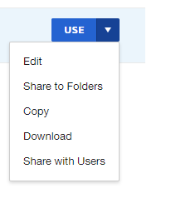
- The template will now be saved in the “My Templates” section located on the left side of the screen.
- Click on “My Templates” and find the saved copy of the template.
- Click “use” on the saved copy of the template.
- The screen will display a list of recipients. Click “Advanced Edit” on the bottom of this pop up.
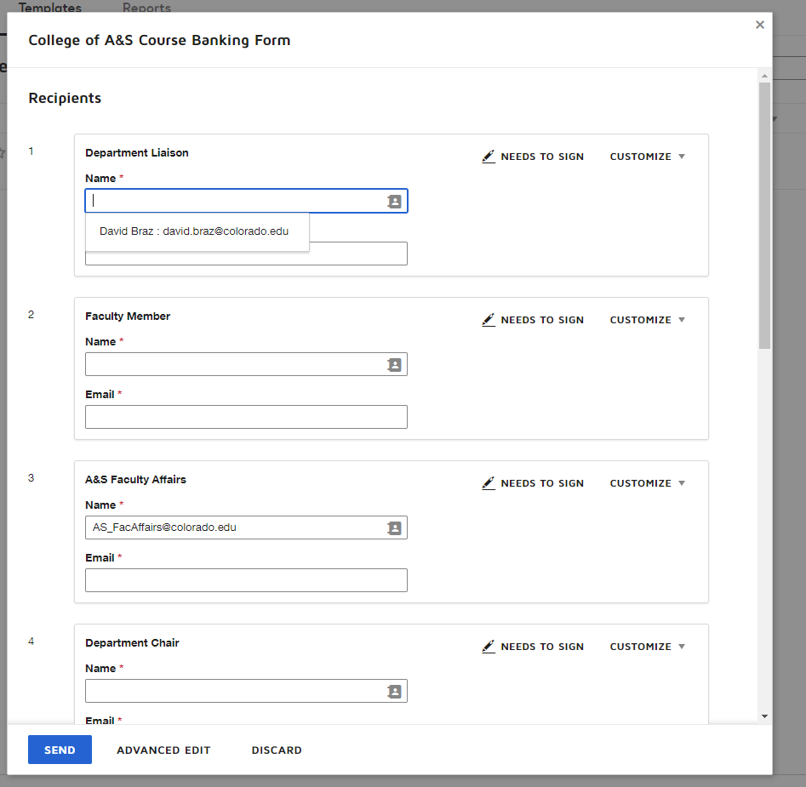

- You will be taken to the “Add Documents to Envelope” screen. The program coordinator can add any additional documentation to the envelope at this stage. Do not replace or change the Course Banking Request document.
- Scroll down to “Add Recipients to the Envelope.”
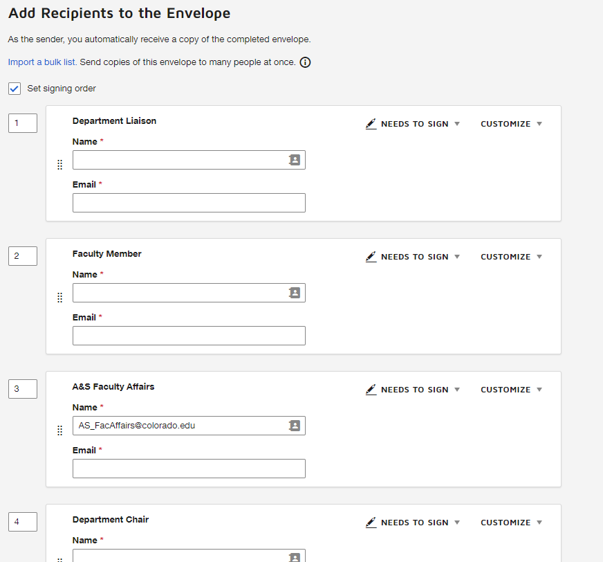
- Add the program coordinator information. It will route to the liaison to enter:
  - Faculty Name (required)
  - Department (required)
  - Number of courses in Current AY teaching load (required)
  - Reason for Banking request / plan for unbanking (required)
    - Fall
      - Year (optional)
      - Number of course(s) requesting to bank during fall (optional)
      - Specific Course(s) (Optional)
    - Spring
      - Year (optional)
      - Number of course(s) requesting to bank during fall (optional)
      - Specific Course(s) (Optional)
- The second recipient is the Faculty Member. Enter their name and email into the recipient field.
- The third recipient defaults to A&S Faculty Affairs. The Faculty Affairs Coordinator (FAC) will check that the banking request has been filled out properly. If the banking request has been filled out incorrectly the FAC will decline to sign and the coordinator will need to resubmit the request.
- The fourth recipient is required. Enter the Department Chair name and email address.
- The fifth recipient is the Institute Director and is optional. Enter the Department Chair name and email address if necessary. Delete this role if unnecessary.
- The sixth recipient is the Graduate School Dean and is optional. Enter the Department Chair name and email address if necessary. Delete this role if unnecessary.
- The seventh recipient is the Associate Dean and is required.
- Click “Add Recipient” if there is a need for more signatures or to add someone to receive a completed copy.
- After the signer and recipients have been added, scroll down to “Message to All Recipients.”
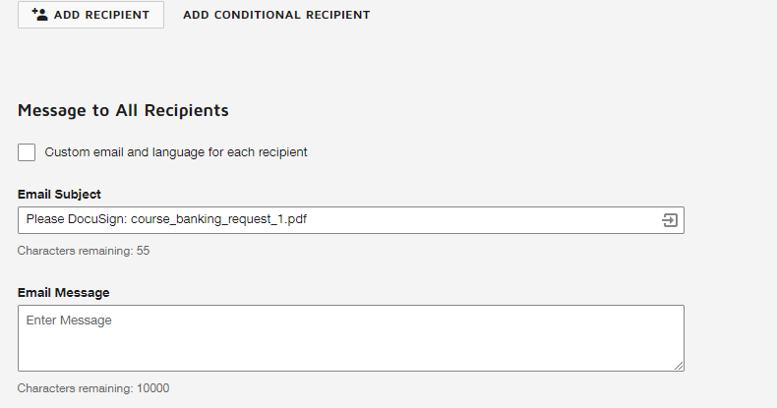
- You can either choose to send a custom email to each recipient, or one email to all recipients. Do this by either checking or unchecking the “Custom email and language for each recipient” box.
- Add any message in the “Email Message” box you would like to have shown while the offer letter is routing signatures.
- Change the email subject line to “Course-Related_DEPT_Last_First_Rank_Course Banking (or) Course Unbanking_Term
  - Example Banking: Course-Related_HIST_Braz_David_Instructor_Course Banking_Fall2021
  - Example Unbanking: Course-Related_APS_Braz_David_Professor_Course Unabnking_Fall2021
- Click “Next” on the bottom of the right of the screen.
- Add signatures for each signatory on the banking form. Signature lines for roles 1-7 are already assigned.
- After any new signature lines have been added, click “Send” on the bottom right of the screen.
- The packet will route to the coordinator to enter information on the form. Fill out all required sections and the optional sections that apply.

