Data S.O.P.

(Standard Operating Procedure)

# Data Analysis

* Remove mini SD card, gently push it in and when you release you should hear a click, then wiggle it out of the holder (to reinsert, gently push it in until you hear a click)
* Use the SD card adapter provided to load the data onto a computer
* The raw data is written to test files in a CSV (comma separated value format), and it is split up by day, the naming convention will tell you what data is in the file (e.g., N2080114 is data from pod N2 from 8/1/2014)

# Excel Notes

* Use ‘*File*’, ‘*Open*’, and then find your data file, you will likely need to change the option in the bottom right corner from ‘*All Excel Files’* to ‘*All Files’* so excel will recognize the .txt files
* Then the ‘*Text Import Wizard’* should open, this will help you split the data into columns; select ‘*delimited*’ on step 1, ‘*comma*’ on step 2, and ‘*finish*’
* You can also import the data and then use ‘*text to columns’* in the ‘*data*’ options

# Plotter Notes

* The Plotter can be downloaded and installed from <http://citizenscienceairqualitymonitoring.pbworks.com>, under ‘*Additional Resources’* and following the link ‘*Data Analysis Tools’*
* There are two parts, the program and our code for the plotter, if you have never used it before be sure to download the package that includes both
* You should then be able to open it and use should be fairly self-explanatory
* Begin by using ‘**Get Data’** to load your first set data, and use ‘**Add Data’** to add files you would like to appear on the same plot
* You can add multiple files at once if they are from the same pod
* You can add files from different pods to the same graph using the ‘Add Data’ option
* **Note**: sometimes errors in the data files can prevent them from loading, if this happened let us know and we can help trouble shoot (it is most likely one stray character, or one line that was not written correctly in the raw file)

# Important Notes

* All monitors use GMT/UTC time and this will need to be corrected for analysis (UTC-6 hrs during the summer, UTC-7 hrs during the winter to reach the correct time in Colorado)
* If you choose to analyze raw data, REMEMBER the data is in the form of raw electronic signal, or voltages, meaning quantitative analysis is not possible, only qualitative

# Data File Column Guide:

***\*(most important, less important)***

* Model – Pod id
* YYYY/MM/DD - Date
* HH:MM:SS - Time
* UnixTime – Unix time, number of seconds from January 1, 1970
* Baseline - Empty
* CO2 – CO2 ndir sensor
* A0 – If there’s a met station, wind direction
* Fig1 – VOC metal oxide sensor
* Fig2 – VOC metal oxide sensor
* e2v03 – Ozone metal oxide sensor
* e2vNO2 – Nitrogen dioxide metal oxide sensor
* e2v1, e2v2, e2v3, e2v4 - Metal oxide sensor (either CO or total VOCs, check Pod)
* Temp – Temperature (degrees Celsius)
* Rh – Relative humidity (%)
* BaroT, BaroP - Empty
* Lat, N/S, Lon, E/W - GPS data
* C0, C1, C2, C3, C4, C5, C6, C7 – Empty (additional add-on space)
* Ba1, Ba2, Ba3, Ba4, Bb1, Bb2, Bb3, Bb4, Bc1, Bc2, Bc3, Bc4 – Empty (space for electrochemical sensor data)
* Wind – If there’s a met station, wind speed

# Sensor Diagram

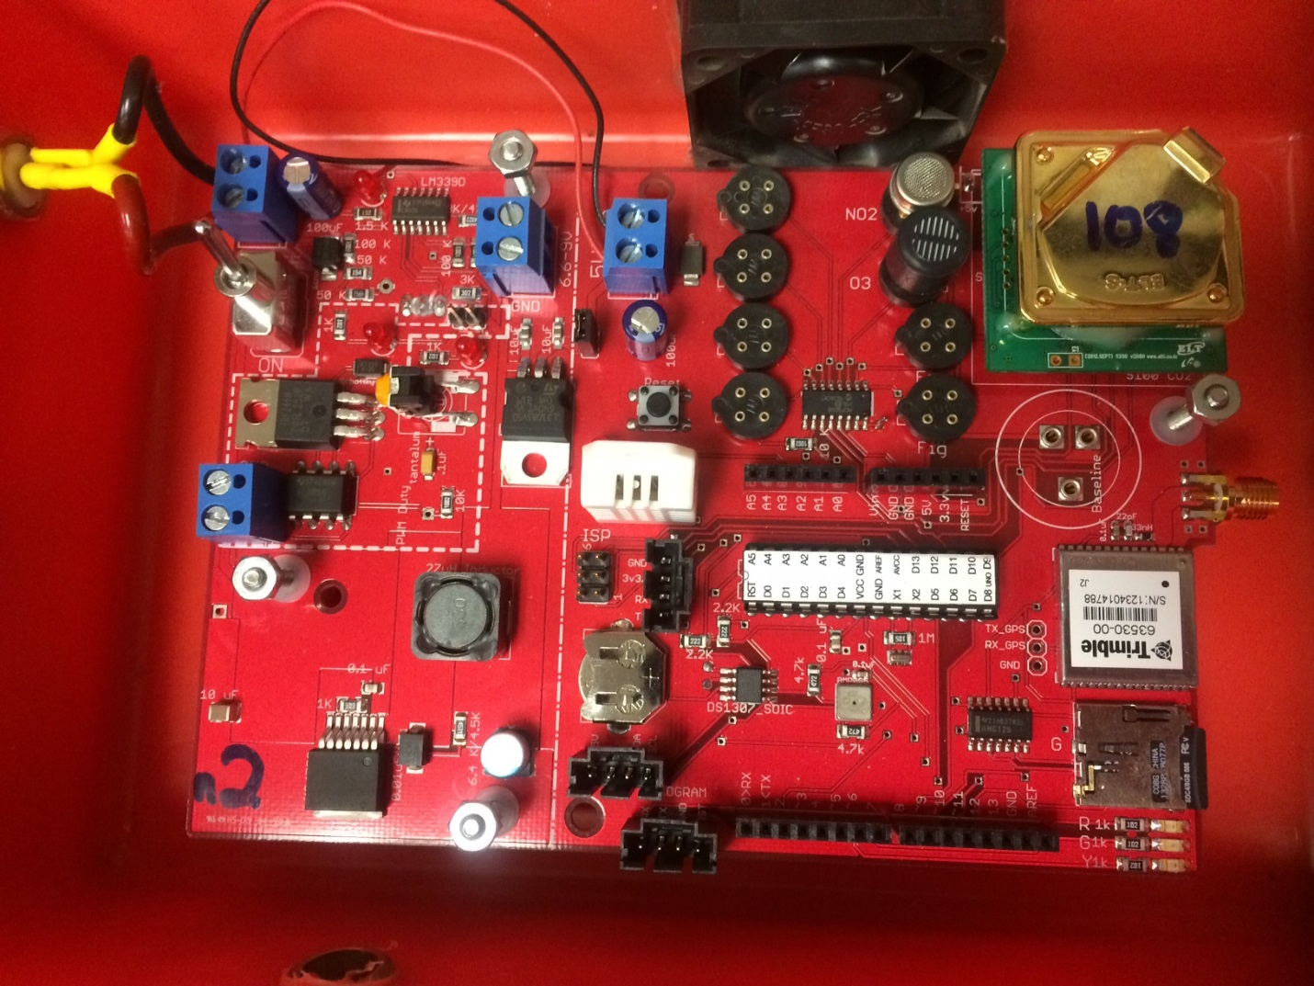

**E2v3**

**Temp and RH**

**E2v4**

**E2v2**

**E2v1**

**O3**

**NO2**

**Fig2**

**Fig1**

**CO2 Sensor**

# Plotter Screen-shot and Key Features

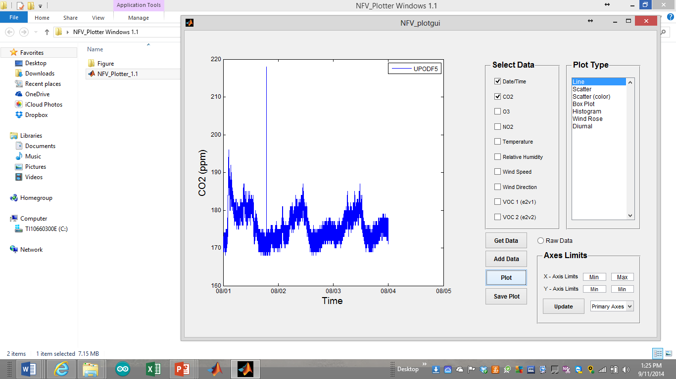

Key Features:

* ‘Get Data’ is the function to import your first data set, which can be one or multiple files, as long as they are all from the same pod (same id number in the data file, e.g., N7)
* ‘Add Data’ allows you to add more data to the same plot, either from a new pod or the same one; again, this can be one or multiple files as long as the multiple files are from the same pod
* Enabling ‘Raw Data’ ensures that your columns are correctly labeled with ‘voltage’ as the units rather than concentration, this is important if you would like to save the plot for reference later
* ‘CO2’ plots data from the CO2 column
* ‘NO2’ plots data from the e2vNO2 column
* ‘O3’ plots data from the e2v03 column
* Temp and RH are as you would expect, although if you using converted data files (concentration rather than voltage, Temperature will be in units of Kelvin (K))
* Wind Speed and Wind Direction will only be available for concentration files, plots will be inaccurate if you plot raw wind speed and direction data, BUT the Wind Rose Plot type is extremely useful for understand
* ‘e2v1’ and ‘e2v1’ plot data from those columns in the data files (check the pod)