How to Use the U-Pod

Standard Operating Procedure

How to Turn On the Monitor
- Power the monitor by plugging in the power cord or battery BNC connector plug to the BNC connector outlet
- Turn the monitor ‘on’ by flipping the silver switch
- Check the monitor function:
  - Is light 1 illuminated? *(see Pod Feature Diagram on Page 2)
  - Is the fan running?
  - Are lights 2 & 3 blinking approximately once per every 5-15 seconds each? (the exact frequency will depend on the monitor’s programming)
  - If the answers to the above questions are ‘yes’, then the monitor is collecting data. Data collection will continue until the monitor is powered off
  - If the answers to the above questions are no, the pod is not working correctly. ERROR CODES – the pod is not working correctly if you see either of these
    - Lights 2 & 3 blinking in unison once per second
      - SD card error – the pod is not recognizing the SD card.
      - Try removing and replacing the same SD card.
      - If that doesn’t work, try inserting a new SD card.
    - Lights 2 & 3 blinking alternatingly once per second
      - Time error – the clock on the circuit board has lost time
      - The pod will need to be re-programmed, contact someone from the Air Quality group at CU Boulder.

Power Option Diagram
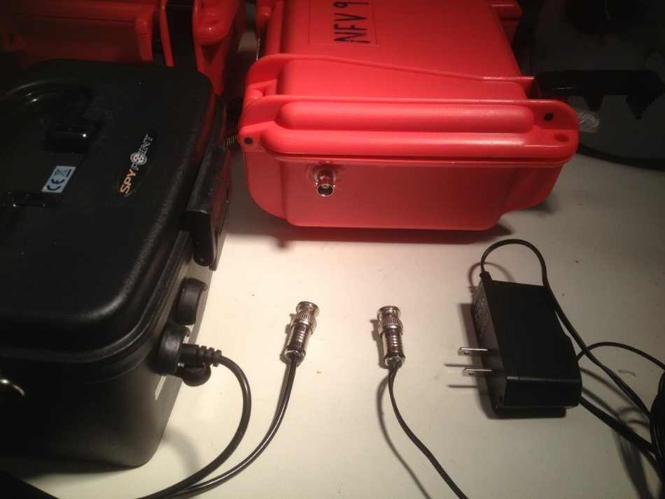
Power Cord
BNC Connector Outlet
Power Cord
Battery
BNC Connector Plug

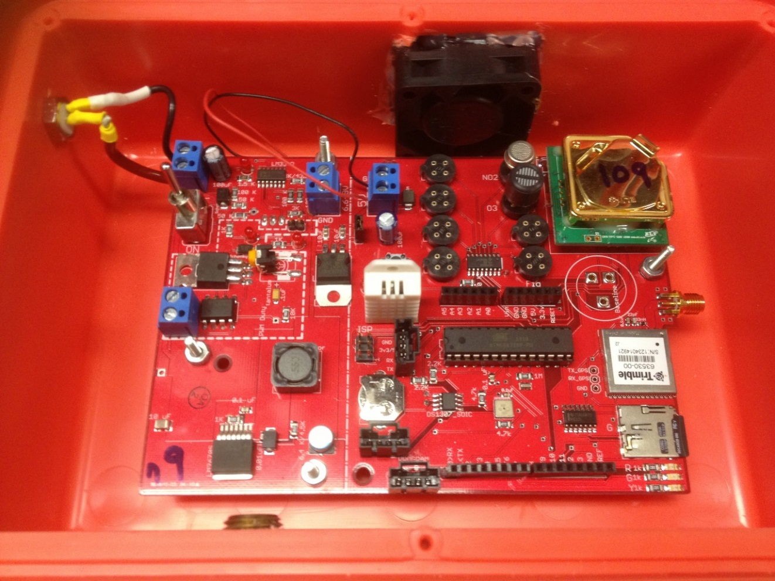
Pod Feature Diagram
Power Switch
(up-off, down-on)
Light 1
Fan
Light 2
Light 3
SD Card
Box Hinges
Box Opening
Use the diagram below to find turn on the monitor and make sure it is working correctly.

Sampling Frequency
The sensors are continuously running, but data is only written to card each time lights 2 & 3 blink; therefore you likely have somewhere between 4 and 12 data points per minute. When processing the data, our group typically takes averages the 4-12 raw data points per minute to create a “minute average” for data analysis.
If you would like to adjust the sampling frequency the device will need to be re-programmed, contact the Air Quality group at CU Boulder for help.

Gas-Phase Species Sensors
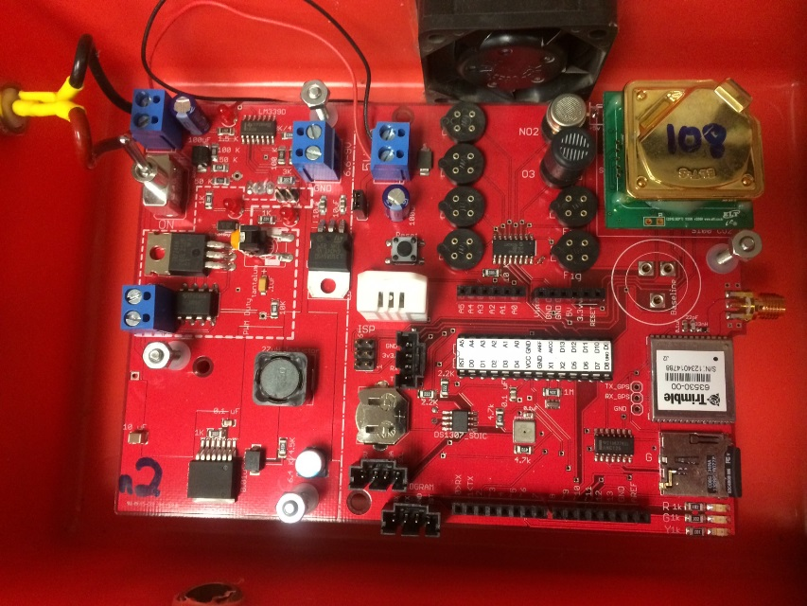
Use the guide below to determine the type of sensor you have.
Non-dispersive infrared CO2 sensor
Metal oxide NO2 sensor
Metal oxide O3 sensor
Place for metal oxide Figaro VOC sensor 2602*

Place for metal oxide Figaro VOC sensor 2600*

These places can use either the e2v CO or VOC sensor

- The Figaro VOC 2602 is sensitive to heavy hydrocarbons only, whereas the Figaro VOC is sensitive to both light and heavy hydrocarbons.
The picture below shows some of the sensors mentioned above. The Firago VOC sensors have silver caps (not black caps). The e2v CO and VOC sensors have black plastic caps, and the e2v CO sensor is approximately twice as tall as the VOC sensor below it.
e2v CO sensor

VOC sensor

Figaro VOC Sensors

Data Storage

SD Card Adapter Mini-SD Card
While the monitor is running data is being recorded to the mini-SD card; the device makes one file per day, so regardless of whether it is run continuously or used intermittently - all data from the same day will end up sequentially written to the same file
- *Note, the text files take up very little space, so do not worry about running out of space (we could probably fit a year’s worth of continuous data on a card)

Some Notes on Sampling

- Keep in mind, the sensors do not respond instantly and they require a warm-up period; a good rule of thumb is to give the monitors 10-30 minutes to warm up before sampling (this gives the sensors time to warm up and adjust to the temperature, essentially time to reach a baseline)
- When sampling be sure to give the sensors time to respond to a stimuli; here a good rule of thumb is 5-10 minutes
- Last note, keep in mind the flow dynamics of the monitor (see the diagram below); and make sure the monitor can effectively pull the sample into the chamber
When the monitor is sealed the fan is pulling the sample in the front inlet and out the vent in the back of the pod, some have an additional opening on the side for the met station cord (this is not the main inlet but will also serve as an entrance for sample air.

Saving/Accessing Data

- Remove mini SD card, gently push it in and when you release you should hear a click, then wiggle it out of the holder (to reinsert, gently push it in until you hear a click)
- Use the SD card adapter provided to load the data onto a computer
- The raw data is written to test files in a CSV (comma separated value format), and it is split up by day, the naming convention will tell you what data is in the file (e.g., N2080114 is data from pod N2 from 8/1/2014)

Important Notes

- All monitors use GMT/UTC time and this will need to be corrected for analysis (UTC-6 hrs during the summer, UTC-7 hrs during the winter to reach the correct time in Colorado)
- If you choose to analyze raw data, REMEMBER the data is in the form of raw electronic signal, or voltages, meaning quantitative analysis is not possible, only qualitative

Data Storage

SD Card Adapter Mini-SD Card

While the monitor is running data is being recorded to the mini-SD card; the device makes one file per day, so regardless of whether it is run continuously or used intermittently - all data from the same day will end up sequentially written to the same file
- *Note, the text files take up very little space, so do not worry about running out of space (we could probably fit a year’s worth of continuous data on a card)

