UNEXPECTED BUDDHA:
THE ILLUSORY VISIONS OF CONTEMPORARY TIBETAN ARTIST, KARMA PHUNTSOK

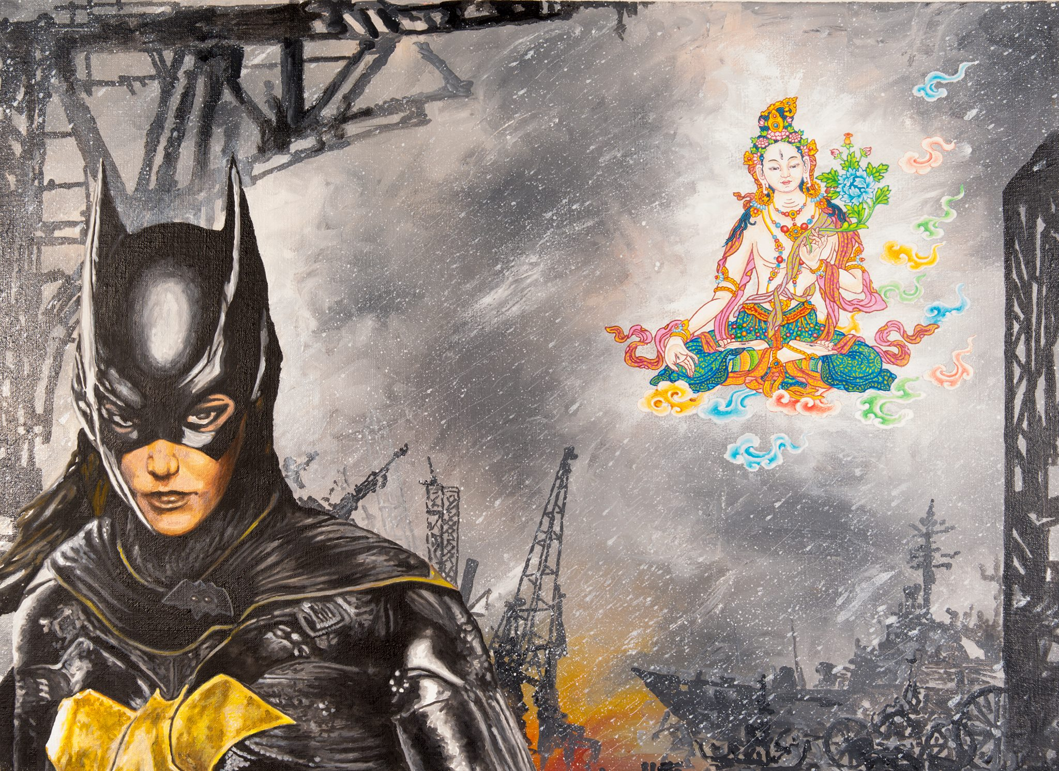Bat Girl (Karma Phuntsok, 2016)

Artist Talk and Slideshow with Karma Phuntsok

Free and Open to the Public
Sponsored by the Tibet Himalaya Initiative – CU Boulder

Thursday, September 1
6:30 pm
University of Colorado, Boulder
Hale Science Building, Room 270

Bio: I was born in 1952 in Lhasa, Tibet. My family and I fled Tibet after the uprising against the Chinese in 1959, escaping into India as refugees. I studied drawing and painting through my school years in India. In 1973, I studied thangka painting with a master of traditional Tibetan thangka painting in Nepal. Since then I have been making paintings based on Tibetan Buddhist deities.

In 1981 I migrated to Australia and now live in the “Bush” north of Kyogle with my wife and son. My paintings are collected world-wide and published in various books and magazines. My recent paintings are mostly experiments, interweaving traditional techniques and symbols with modern inspirations.

