Concur Request (Aero Center, Finance Manager Needed):

Please proceed by filling out your Concur request form prior to making travel arrangements.

- In the upper left-hand corner go to the Home dropdown and select “Requests”.
  - 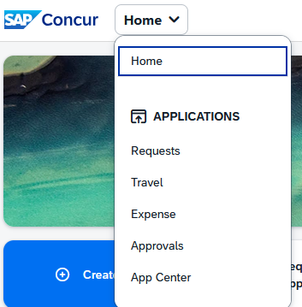

- In the upper right-hand corner click on the "Create New Request".
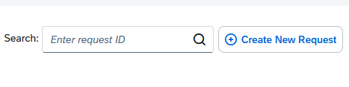
- Fill out the information on the form. In the "Additional Information" area add the travel justification, the reason for this travel and how it benefits the project you are charging. In the “Submit Requests to” dropdown, select “Speedtype (Finance Fiscal Roles)”. If your trip is split between multiple speedtypes, add all the speedtypes and allocations to the Comment area of the header. Then click “Create Request” button in lower right corner.
- 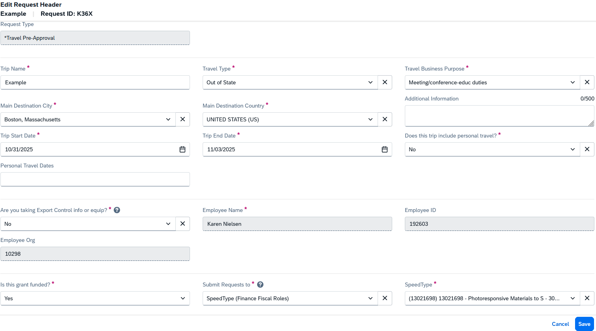

- You will be taken to the general page of the request. Click on "Request Details" and then "Request Timeline".
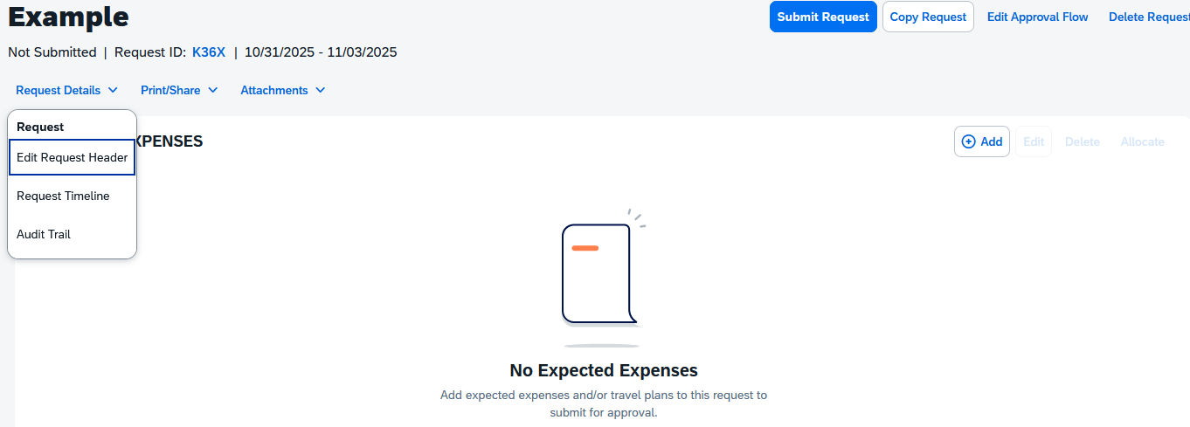

- Next, you'll click Edit.
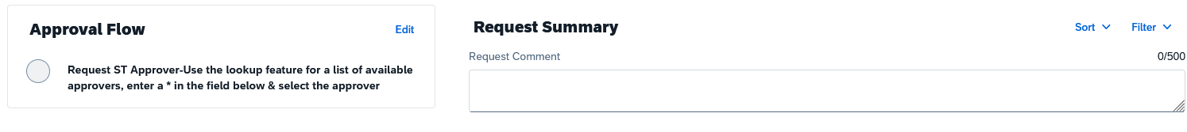

- Search for and add the Finance Manager for your Aero Center, then click Save.

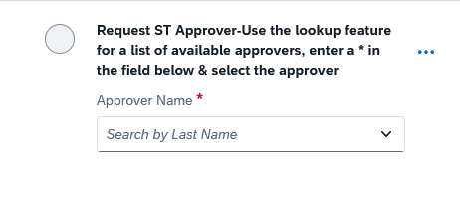

- While you are in this screen/step, you can select both your speedtype approver and manager approver. Drop down from the three dots and select “Add below this step”
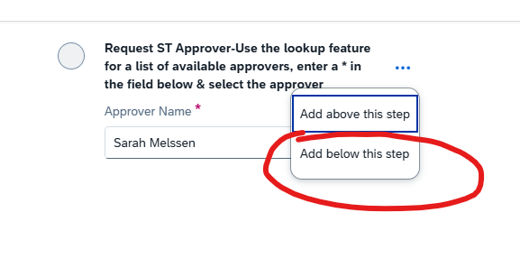
- A “New Approver” field will pop up. Select your supervisor/faculty adviser/PI name.
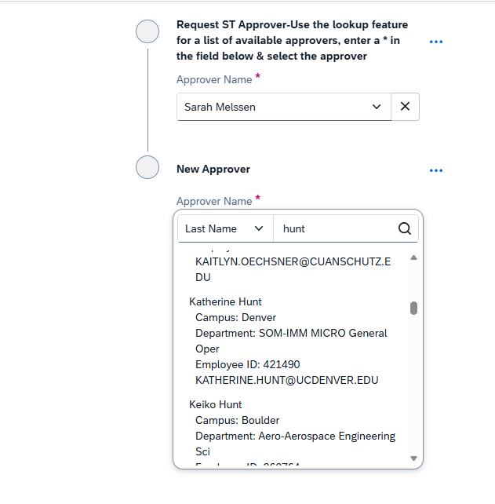

- Save your selection, and you will see your selected Approval Flow in the pop-up menu.
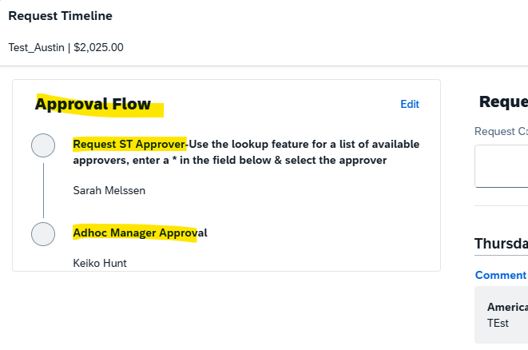

- Next add your expected expenses for the trip by clicking the "Add" button. Once the approval flow is updated and your expenses are added, you can submit your request for review and approval. You will click on the “Submit Request” button in the upper right-hand corner of the request.
