# Sponsor Guidelines AY 2023/24

Senior Projects (ASEN 4018 & 4028)

## Introduction

All undergraduates in the [Ann and H.J. Smead Aerospace Engineering Sciences (AES)](http://www.colorado.edu/aerospace/) department at the University of Colorado Boulder are required to take a two semester capstone projects course sequence; *ASEN 4018 Senior Projects I: Design Synthesis* (Fall semester) and *ASEN 4028 Senior Projects II: Design Practicum* (Spring semester).The course is taught by a team of faculty and staff members whom make up the Project Advisory Board (PAB). The purpose of the AES Senior Projects course is to provide undergraduate AES students with a first-hand experience of a requirements-based design process. Projects for the course are developed by faculty to align to current interests and technology applications in the aerospace industry defined by specific functional objectives. All projects provide significant design challenges that allow students to explore various design trades and develop a final design based on engineering analysis, prototyping, and test. The student teams must apply fundamental engineering principles to design an aerospace system which meets the customer requirements. Further, student teams must communicate a strong engineering understanding of their system design to the PAB at four design reviews. Projects are scoped to a level of complexity that is compatible with 8-12 person teams of engineering seniors working an average of 16 hours each per week for 28 weeks.

## Senior Projects Course Content

Senior Projects is a rigorous two-semester design course where students utilize systems engineering principles to develop and integrate complex designs that require multiple subsystems. In the fall, student teams begin with requirement development, conduct trades, perform feasibility analyses and prototyping, and present a detailed design. In the spring, teams procure materials, fabricate the designs, integrate and test, and analyze test data to attempt verification and validation of the design. Teams must close the loop between their analysis and model predictions from the fall and the actual test data in the spring. Finally, students use the conclusions from testing and model comparisons to suggest improvements to their recommended design for future work. Students work in self-directed teams which consist of 8-12 aerospace engineering seniors. Each student must have a well-defined role on their design team, and demonstrate leadership in at least one aspect of project development and execution. Each team is advised by one faculty member from the Project Advisory Board (PAB). These faculty members cover a wide range of technical skills and design experience to guide the teams through the design process, which is augmented by other members of the PAB. Advisors formally meet with their teams for at least one hour each week. Course details and schedule, including reviews, are shown in Figure 1 below.

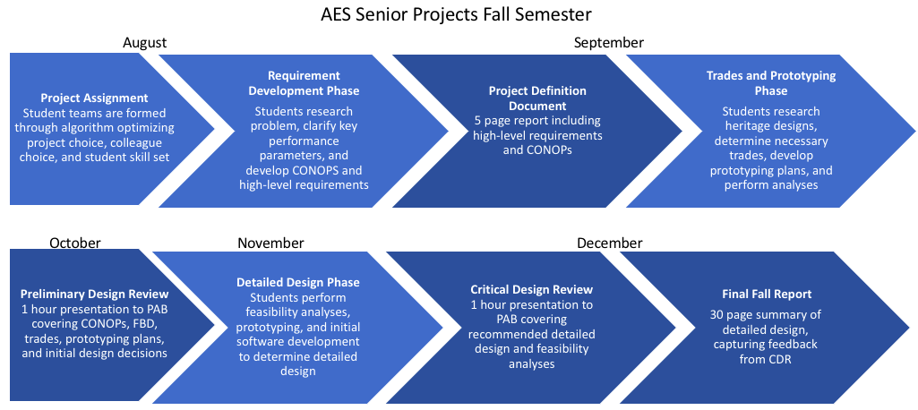

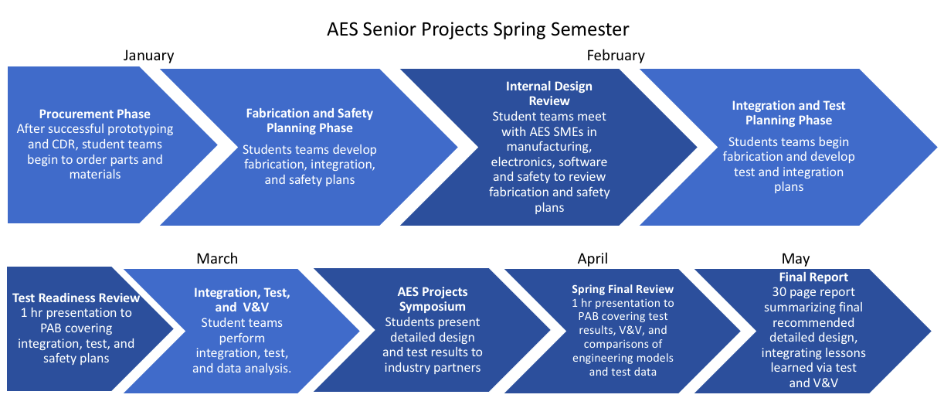

Figure : Senior Projects course details and schedule. Light blue blocks indicate design phases, while dark blue blocks indicate design reviews or deliverables.

## What is Expected from Project Sponsors?

Companies, national laboratories, R&D organizations, organizations and individuals interested in philanthropic giving, and academic faculty members may become project sponsors. Within the framework of the Senior Design course, all projects are conducted on a best effortbasis by students, guided by a member of the AES PAB. Sponsors can participate in the AES Senior Projects program by contributing $15K to support projects that are scoped by AES faculty members and designed to train students in relevant engineering and program management skills. This ensures students have a faculty advisor with a technical background in the project area to help guide and accurately assess the design, analyses, and test procedures. Further, the program seeks to maintain strong AES student-industry relations while reducing the logistics that came from running a large variety of projects at a time for 200+ students each year. Sponsors can attend any design review of any team, and have the option of mentoring a team.

Each faculty advisor for senior projects will scope a project that has high industry impact while being in the faculty member’s area of expertise. Projects will allow for an open-ended design space with multiple key performance parameters, require integration across sub-systems, and allow for both software and hardware design. Faculty members have extensive experience scoping projects that will challenge the students, allowing opportunities for failure and recovery.

### Three teams will be assigned to each PAB member’s project scope. While three teams will each share the same high-level project scope, each team will work independently and develop their own design that may optimize different key performance parameters. Teams will execute the design-integrate-test cycle described in Figure 1 with the faculty member transitioning from a customer role to a technical mentor role mid-fall semester.

### Sponsors will receive a summary of planned projects over the summer, and a dossier in early September outlining the course schedule, design review dates, and student project teams. Sponsors have the option of attending any design review for any team, which is a great opportunity for recruiting as design reviews begin in early October. Sponsors will also receive access to the final fall and spring reports for all teams, and an invitation to the Sponsor Kick-off Night early in the fall semester and the AES Senior Projects Symposium in April. The Sponsor Kick Off event is limited to sponsors and gives them exclusive access to the seniors early in the fall semester. Sponsors are invited to bring their talent acquisition leads to this event. The AES Projects Symposium is a large event in the spring semester and invitations are sent to a broad array of industry and government partners, aerospace alumni and leaders in the aerospace industry. As a result, having the names of all sponsor organizations displayed at this event will raise the sponsor’s visibility with our students, faculty and other aerospace stakeholders.

### Sponsors may choose to mentor a team throughout the academic year from a technical, teamwork, and program management stand point. This can be seen as a “9-month interview” for potential future employees. A sponsor’s return on investment are the students and building a workforce development pipeline; over the course of two semesters (28 weeks), a student team of 8 - 12 members is required to spend at least 4500 – 5000 person-hours working on their senior project. Sponsors will be informed of the broad areas that will be covered that year and can request to mentor a team in the area that match their interests, and these requests will be assigned on a first come, first serve basis.

### Sponsors shall complete a standard Notice of Intent (NOI) form and submit it to the AES Senior Projects Coordinator. The NOI must provide the name and contact information of the sponsor’s contracting expert, who will work with the University’s contracting department to set-up the necessary structures to be a senior project sponsor. The contracting expert should be the one to sign the NOI on the sponsor’s part. If the sponsor wishes to mentor a team, the sponsor should also provide the name and contact information of the team mentor to the AES Senior Projects Coordinator.

## AES Senior Projects Student Team Resources

AES facilities, staff, and faculty are resources for all senior projects. Each team is assigned one faculty advisor from the Project Advisory Board (PAB) pool, who will meet with the team weekly to give technical guidance and assess progress. Project teams may also be assigned an industry sponsor mentor that can provide mentorship on communication, program management techniques, technical design decisions, and career pathways.

All senior design teams have priority access to the AES manufacturing facilities and electronics labs. The students receive design and manufacturing guidance from a full-time machinist, and manufacturing, electronics, and software advisors.

All faculty members in AES have agreed to support senior design teams if approached with project related questions, providing a broad and deep base of expertise and experience for the students to draw upon. Students are also encouraged to seek out other sources of expertise, information, and advice from industry and the engineering literature to support their design decisions.

## Project Sponsorship

AES has established a preferred avenue for sponsors who would like to support the two-semester senior design project course, and a corresponding standard contract template. An outline of this support is provided below:

**Sponsor support**. An AES Senior Design Project requires a **funding level** of **$15,000** which is subdivided as follows:

* Project-specific expenditures for project-specific materials, parts, software: $4000 minimum. Amount varies by project at the discretion of the sponsor as well as project needs.
* Department infrastructure and labor fees for the senior projects (instructors and shop staff salary, maintenance for manufacturing shop, electronics shop, computer labs, materials, supplies, disposables, and other department functional staff): $11,000.
* If a project mentor wishes, additional in-kind support (e.g. lending of hardware, access to test facilities, etc.) may be provided, depending on the focus and scope defined for the project.

Sponsor agreements can be completed as either a contract through the CU Boulder Office of Contracts and Grants or as a 501(c)(3) philanthropic gift through the CU Foundation. The support agreement shall be in place no later than May 31st and the funding in place no later than June 30th.

Where do your funds go: Over the past years of teaching senior projects, the AES department has committed a considerable amount of general funds resources to develop the curriculum and materials for the Senior Projects course. Further, undergraduate student enrollment in AES has nearly tripled in the past 10 years, with a projected enrollment of 250 students in senior projects for AY23/24. Budgetary constraints require that external funding be sought to supplement department costs so that our program remains sustainable and allows us to continue educating some of the best aerospace engineers in the world. The departmental staff and faculty members contribute a substantial number of hours (ranging from 60-100% of their time) with the teams to guide project success; thus a portion of their salaries and those of auxiliary support staff must be covered by the senior design project funding.

All components purchased from project funds will remain in the AES department for possible future use in another project or class.

## Sponsor Benefits

Sponsors are invited to the following events:

1. Sponsor Kick Off (Fall)

The Sponsor Kick Off event is limited to sponsors and gives them exclusive access to seniors early in the fall semester.

1. AES Project Symposium (Spring)

The AES Projects Symposium is a large event in the spring semester and invitations are sent to a broad array of industry and government partners, aerospace alumni, and leaders in the aerospace industry.

Sponsors are invited to the design reviews for all senior project teams:

1. Concept Review (CR). A 30 minute presentation highlighting planned trades, feasibility analyses, and prototyping. Review occurs in early October.
2. Critical Design Review (CDR). A 30 minute presentation highlighting engineering models and detailed design
3. Test Readiness Review (TRR). A 30 minute presentation highlighting test and V&V plans.
4. Spring Final Review (SFR). A 30 minute presentation highlighting test results, V&V conclusions, and any recommended design changes.

Sponsors will receive access to the following documents for all teams:

1. Project Definition (PDD). 5 page document summarizing CONOPS and high level requirements.
2. Fall Final Report (FFR). 30 page document containing a summary description of the design at the CDR level.
3. Project Final Report (PFR). 30 page document summarizing final design, integrating recommendations after testing.

If desired, sponsors have the option to mentor a team from a technical, teamwork, and program management stand point. This can be seen as a “9-month interview” for potential future employees.

**Address:**

Ann & H.J. Smead Department of Aerospace Engineering Sciences

University of Colorado Boulder

429 UCB

Boulder, Colorado 80309-0429

<http://www.colorado.edu/aerospace/>

Dept. Phone: (303) 492-6417

| **Recent External Sponsors** |
| --- |
| AeroVironment |
| Astroscale |
| Ball Aerospace |
| Blue Origin |
| EchoStar |
| EnerSys |
| General Atomics |
| NASA – Jet Propulsion Laboratory |
| L3Harris |
| Lockheed Martin |
| The Aerospace Corporation |
| United Launch Alliance |

**History of Recent Projects**

Potential sponsors are encouraged to visit the AES Senior Design course webpage at <http://www.colorado.edu/aerospace/current-students/undergraduates/senior-design-projects> to browse recent projects and to examine the project deliverables.

**Contacts**

| **Title** | **Name** | **Email** |
| --- | --- | --- |
| Department Chair | Dr. Hanspeter Schaub | [Hanspeter.Schaub@colorado.edu](mailto:Hanspeter.Schaub@colorado.edu) |
| Course Coordinator | Dr. Kathryn Wingate | [Kathryn.wingate@colorado.edu](mailto:kathryn.wingate@colorado.edu) |
| Industry & Alumni Relations Manager | Claire Yang | Claire.Yang@colorado.edu |