Tree thinking pretest

This quiz assesses your general understanding of how to interpret and draw valid inferences from phylogenetic tree diagrams. Note: this will give you a sense of how much you stand to learn, but does not claim to be a formal, educationally-validated assessment of tree-thinking.

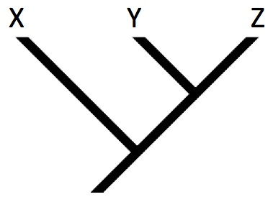

1) Which of the following is a correct interpretation of the tree shown?

1. Z is the most advanced species
2. X is the most ancient species
3. Y is an intermediate between X and Z
4. All of the above
5. None of the above

2) Referring to the same tree, which statements about common ancestry hold?

1. X is the common ancestor of Y and Z
2. Z is the ancestor of first X and then Y
3. The common ancestor of X and Y lived after the common ancestor of X and Z
4. Y and Z share a more recent common ancestor than Y and X
5. None of the above

3) Consider the tree to the right. Viridiplantae is defined to include all the descendants of the last common ancestor of volvox and land plants. Which tips are not in Viridiplanta?

1. Nori
2. Mesostigma
3. Nori, Mesostigma
4. Nori, Mesostigma, Sea lettuce
5. Nori, Mesostigma, Sea lettuce, Spirogyra, Chara

4) Which of the four trees below depicts a different pattern of relationships than the others? If they are all the same, pick “e.”

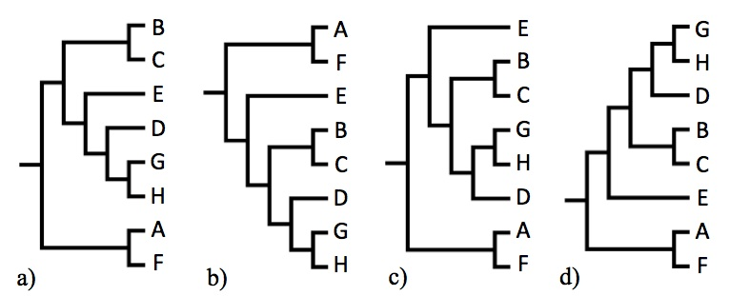

5) Which of the four trees below depicts a different pattern of relationships than the others? If they are all the same, pick “e.”

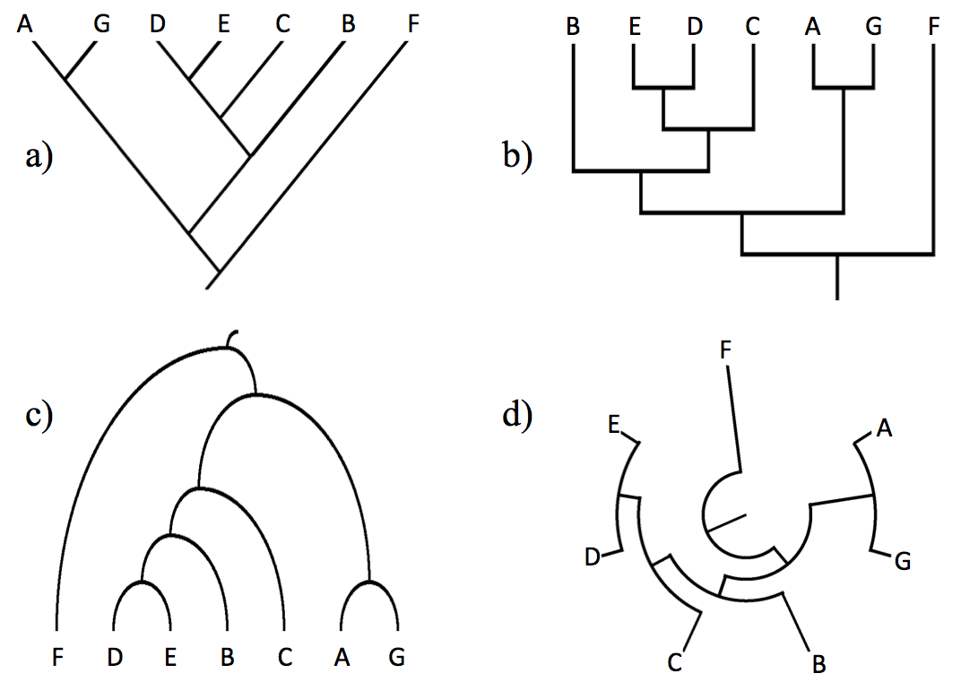

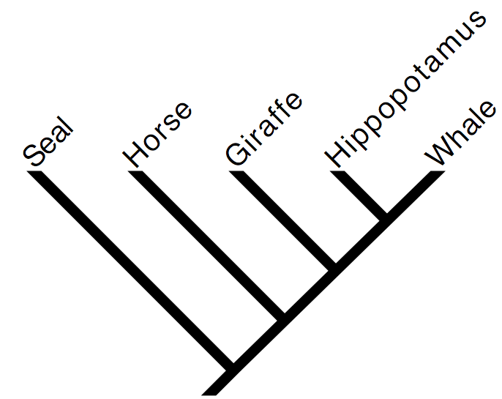

6) By reference to the tree to the right, which of the following is an accurate statement of relationships?

1. A seal is more closely related to a horse than to a whale
2. A seal is more closely related to a whale than to a horse
3. A seal is equally related to a horse and a whale
4. A seal is related to a whale, but is not related to a horse
5. None of the above

7) Which of the following trees is consistent with these taxonomic statements about insect orders: Termites and cockroaches are each other’s closest relatives. The common ancestor of thrips and grasshoppers is the earliest node in the insect tree. Mantises are more closely related to termites than they are to thrips. If none are consistent, pick “e”.

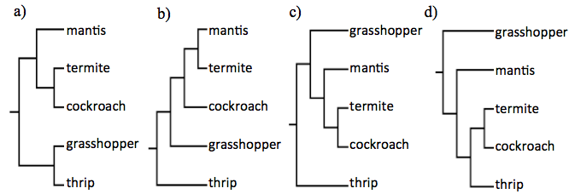

**8-11 Refer to the tree to the right.** Time runs left to right. Living taxa are lined-up at the right of the figure (A, B, D, F, H, I, and J). The branches leading to fossil taxa (C, E, and G) terminate before the present. Numbers represent trait evolution. Assume that all trait changes relevant to the questions are shown. When two traits are mapped to a single branch do not assume that we know the order in which they evolved.

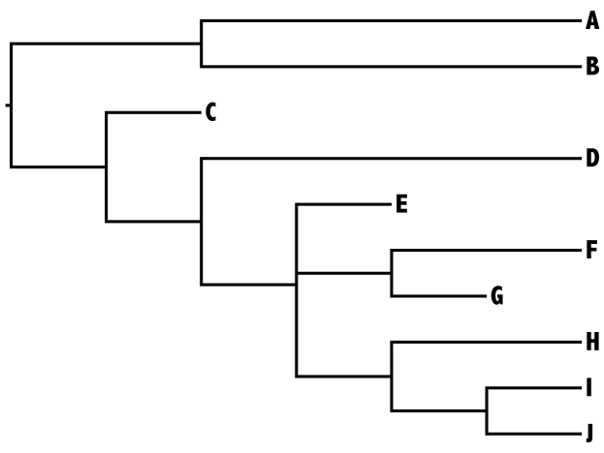

**2**

**1**

**3**

**4**

**5**

**7**

**6**

8) Given this tree, which trait combination is expected in taxon E?

1. 1, 2, 3, 4
2. 1, 2, 3
3. 2, 3
4. 3
5. 4, 5, 6

9) Suppose we found a new fossil that attaches to the branch on which traits 5 and 6 evolved (circled). What combination of traits could be found in these fossils?

1. 2, 3, 5
2. 2, 3, 5, 6
3. 2, 3
4. All of the above
5. Exactly two of answers a-c are correct

10) Consider one of the bars marking trait origin. What underlying phenomena would this bar most likely represent?

1. A trait arising (through mutations) and going to fixation
2. A trait occurring in one member of an ancestral population
3. The reproduction of individual organisms
4. The origin of a new species
5. Lateral gene transfer

11) A newly discovered living species is more closely related to F than to D. Which trait(s) must it have?

1. 1
2. 2
3. 1 and 2
4. 2 and 3
5. 2 and 3 and 4

12-14) Refer to the tree below. The square marks the branch where a vertebral column arose. All descendants of this lineage have a vertebral column and are called “vertebrates”. The circle marks the branch where collagen and embryo formation evolved. All descendants of this branch are called animals.



12) The term “Invertebrates” has historically been applied to include all animals that lack a vertebral column. Which of the following is not an invertebrate?

a) Frog

b) Sponge

c) Mollusc

d) Arthropod

e) Cnidarian

13) Which of the following is a true statement about “invertebrates.”

a) Invertebrates are all more closely related to each other than to any non-invertebrate

b) The traits that all invertebrates share are those that were present in the first animals

c) Some invertebrates (e.g., starfish) are more closely related to vertebrates than they are to other invertebrates (e.g., insects)

d) b & c are both correct

e) None of the above is correct

14) Each internal branch on this tree is an ancestor of 1 to 19 of the listed tips. Which of the following branches exists on this tree?

a) Ancestral to plants and fungi, but not mammals

b) Ancestral to plants and mammals, but not fungi

c) Ancestral to mammals and frogs, but not salamanders

d) Ancestral to molluscs and sharks, but not jellyfish

e) Ancestral to reptiles and sharks, but not ray-finned fish

15) Supposing you collapse animals into a single clade. Which of the following trees would correctly show the relationships of animals to the non-animal groups?

a) 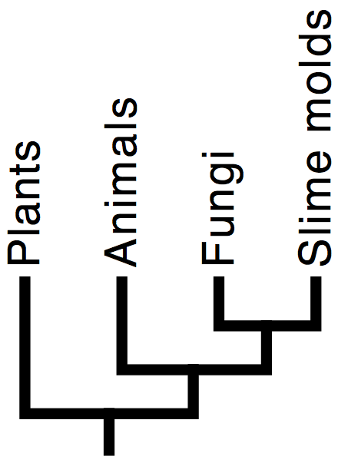 b)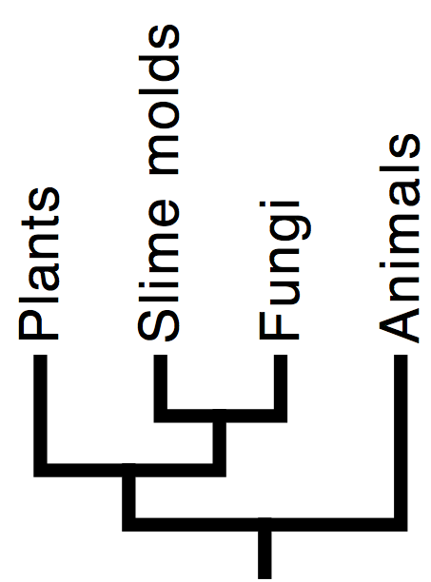 c) 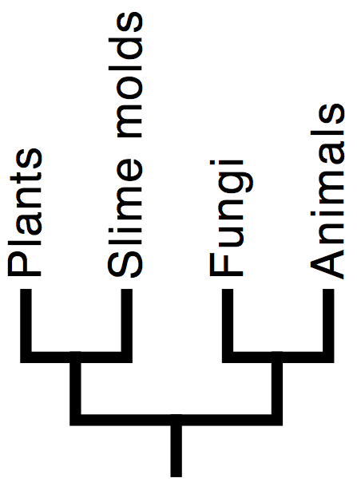

d) 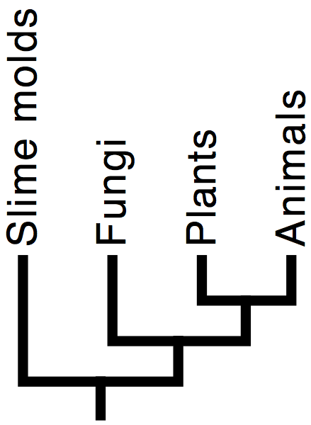 e) 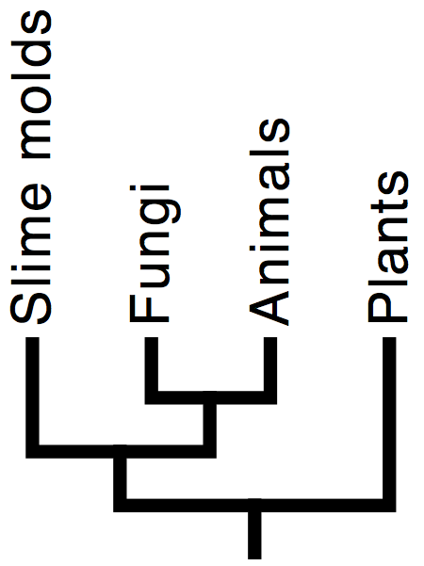

KEY TO QUIZ

1) **e.** All three tips, X, Y, and Z are alive today and have same amount of time to evolve (the same root to tip distance). There is no biological sense in which one is more advanced than another – and even if there were, it could not be read off such a tree diagram. It also invalid to view one tip as intermediate between others.

2) **d.** The last common ancestor of Y and Z (marked YZ) lived closer to the present than the last common ancestor of Y and X (marked XYZ). This can be seen because YZ is a descendant of XYZ. Answers a and b are ruled out because no living species is ancestral to another living species (see also question 1). Answer c is incorrect because the common ancestor of X and Y is the same as the common ancestor of X and Z (marked XYZ on the right).

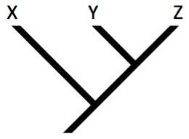

YZ

XYZ

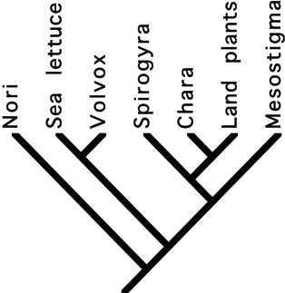

V

3) **a.** The last common ancestor of Volvox and land plants lived at the node marked V. The only tip that is not a descendant of this node is Nori.

4) **a.** This tree differs in placing E sister to (DGH) whereas the other trees have (BC) sister to (DGH). Or, put another way, tree a has a clade, (EDGH), which conflicts with the clade (BDDGH) found in the other trees.

5) **c.** In this tree, the sister to (DE) is B, whereas the other trees have C in this position.

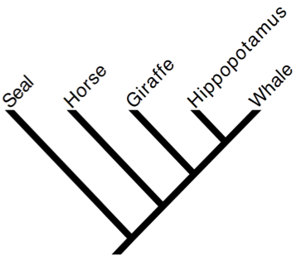

HW

SHW

6) **c.** The last common ancestor of a horse and seal, the node marked SHW, is also the last common ancestor of a horse and a whale. This follows because the last common ancestor of a horse and a whale, marked HW, is a descendant of SHW.

7) **c.** Termites and cockroaches are sister taxa only in a, c, and d, thus b is eliminated. Among these three, the common ancestor of thrips and grasshoppers is the earliest node in c, and d but not in a, where grasshoppers and thrips form a clade. Finally, mantises are more closely related to termites than thrips in c, but not in d (where they are equally related to termites and thrips).

8) **c.** Tracing back from tip E to the root of the tree, we see that only two traits accumulated during its history, 2 and 3.

9) **e.** The fossil could come from a part of the branch before traits 5 and 6 evolved, in which case it would only have traits 2 and 3. Or it could attach after both 5 and 6 evolved, meaning it would have all four traits. Depending on the order of evolution of 5 and 6, it could have either one of them in addition to 2 and 3. When two traits are mapped to a single branch do not assume that we know the order in which they evolved.

10) **a.** Trait changes marked on a tree indicate one or a series of mutations each of which became fixed in the ancestral lineage and resulted in all members of the lineage having the derived trait.

11) **b.** This newly discovered living species could not have trait 1, or it would be equally related to F and D. It could have just trait 2 - if this species attaches to the lineage on which trait 3 arose – but before the evolution of trait 3.

12-14) Refer to the tree below. The square marks the branch where a vertebral column arose. All descendants of this lineage have a vertebral column and are called “vertebrates”. The circle marks the branch where collagen and embryo formation evolved. All descendants of this branch are called animals.



SV

SI

MS

12) **a.** These are all animals, since they all descended from the branch marked with a circle. Therefore, the only way to not be an invertebrate is to have a vertebral column. The only listed taxon that is a descendant of the branch with a square is the frog.

13) **d.** The last common ancestor of a starfish and a vertebrate (SV) lived more recently than the last common ancestor of starfish and insects (SI). This shows that answer c is correct and answer a is false. Since the last common ancestor of all invertebrates (marked with a circle) is also the last common ancestor of all animals, the traits shared by all invertebrates should be ancestral traits of all animals.

14) **d.** The branch marked MS is ancestral to both molluscs and sharks, but is not ancestral to jellyfish.

15) **e.** The first thing to note is that fungi and animals are sister, which rules out trees A, B, and D. Tree C is incorrect because it implies that slime molds are more closely related to plants than to fungi/animals, whereas the reverse is true. Put another way, tree E is the only tree with both a fungi+animal clade and a fungi+animal+slime mold clade.