University of Colorado
Summer Salary Guidelines for Boulder Campus

Summer 2017

- Overview

The guidelines and examples outlined in this document describe the technical aspects of applying the 3/9^{ths} rule to ensure not only compliance with federal and University polices, but also that the faculty member can earn the maximum allowable summer salary. These guidelines are applicable to all units on campus that have academic year appointed faculty who teach or conduct summer research and must be consistently applied throughout the campus. Non-compliance places the University in jeopardy and could result in an audit finding.

Planning
Since summer months are split by the academic year, it is important for a faculty member to carefully plan how they intend to earn their summer compensation. Please use the tool to help plan and calculate: 3/9ths Request Form & Planning Tool

- Calculating Summer Pay

Example A: Professor X’s academic year salary is $72,000. She teaches one overload class in the fall for $5,000 and is the Associate Chair of her department, which pay 2.5% of her academic year salary or $1,800 ($72,000 x 2.5%). The maximum she can earn during the summer months is $24,000 ($72,000 / 9 = 8,000 x 3). The compensation earned for the overload appointment and the associate chair stipend are not included in this calculation.

Faculty members serving as summer chair or faculty director earn 1/12th of the approved administrative stipend each month he/she serves in these capacities. The entire administrative stipend cannot be paid out during the 9-month academic year period as doing so violates a State Fiscal rule which prohibits salary from being paid before it is earned.

Example B: Professor X (see Example A) earns $4,000 for teaching a Term B summer session class and an additional $4,000 for teaching a Maymester class, or a total of $8,000 for summer teaching. Since her 3/9^{ths} limit is $24,000, she can only pay herself an additional $16,000 (24,000 - 4,000 - 4,000 = 16,000) from her grant to remain in compliance with the 3/9^{ths} rule. She could also perform consulting services outside of the University and the compensation earned from those services would have no impact on her 3/9^{ths} limit.

Begin and end dates for calculating the 3/9^{ths} total
The 3/9^{ths} limit is based on compensation earned during the fiscal year (July 1 – June 30) and not during the calendar summer months (May – August). In other words, the compensation earned in the period July 1st through the end of the summer session, typically in early August, added with the compensation earned in the period beginning with the summer session, the Monday after the academic year commencement in May, through June 30th cannot exceed the 3/9^{ths} limit It is important to remember the final 1/9th academic year payment received in the May pay period does not count towards the 3/9^{ths} limit as the effort related to this payment was expended prior to the start of the summer session.

For clarity, this document will refer to the 3/9^{ths} period as July, August, May, and June and uses a typical fiscal year identified as 20xx – 20xy with the dates of the August summer session as 8/1/xx to 8/9/xx and the dates of the May summer sessions as 5/12/xy to 5/31/xy to illustrate the summer session calculations. The actual begin and end dates of any given fiscal year can be found on the Registrar’s website in the Calendars and Schedules link.
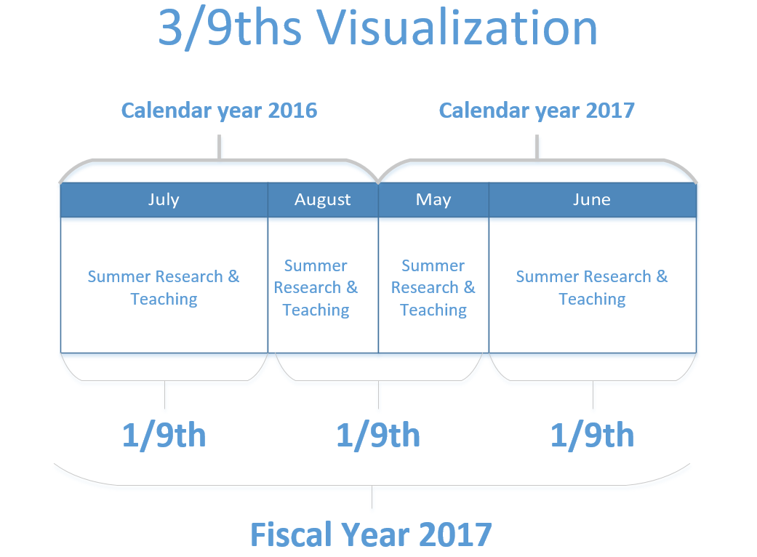

Rate of Pay
Increases to academic year salaries are typically reviewed in the spring. Per Regent policy, implementation of adjustments usually is effective the first day of each fiscal year. Therefore, the 3/9^{ths} limit is calculated beginning July 1st based on the new academic year salary. Every July, compensation rates for research appointments funded from grants must be recalculated on the basis of the new approved rate of pay.

Example C: Summer appointments with an effective date from the beginning of the summer session (mid-May) through June 30th are calculated based on the academic year salary the faculty member received during the previous fall and spring semesters. Appointments with effective dates of July 1st through the end of the summer session (mid-August) are calculated based on the academic year salary the faculty member will earn the upcoming fall and spring semester. If a faculty member plans to be paid from a research grant the entire calendar summer (May – August), the compensation rate must be adjusted on July 1 to reflect his/her new salary.

Salary Rates for Summer Teaching

The salary rates for summer teaching are set by the school/college based on faculty rank. In some situations, 1/9th of a junior faculty member’s salary may be less than the summer rate. To limit the salary to 1/9th for these faculty members would prohibit the opportunity to teach in the summer session. In this situation, the 1/9th rule would not apply, as long as the faculty member is not doing any research during the month he/she is teaching the course. However, the 3/9^{ths} limit still applies.

Example D: Professor Z’s academic year salary is $60,000. His 3/9^{ths} limit is $20,000 and his 1/9th limit is $6,667. During the month of July 20xx, he wants to teach a summer course of which the posted salary is $7,000; Term B in summer 20xx runs from 7/2/xx to 7/31/xx. Even though the salary exceeds his 1/9th, he can earn the entire $7,000 as long as he does no research during the month of July. However, he will need to reduce the amounts he can earn between August 20xx and June 20xy to stay in compliance with the 3/9^{ths} rule.

Example E: Professor Y’s academic year salary is $97,000. Her 3/9^{ths} limit is $32,333 and her 1/9th limit is $10,778. She would like to teach two summer courses in July 20xx (Term B) which pays $9,700 per course; she has no plans to conduct research during the summer. Earning $19,400 in a month exceed her 1/9th limit so she would be in violation of the rules if she is allow to teach the two courses even though the compensation is derived solely from teaching. She does not qualify for the exception because her compensation for teaching one summer course is less than her 1/9th limit. In other words, she cannot exceed the 1/9th limit because 1/9th of her academic year salary ($10,778) is not less than what she can earn teaching in the summer session course ($9,700).

- Frequently Asked Questions

Q 1: My faculty member is teaching a class in Term B that pays $4,000. She plans to supplement her salary by researching. The class begins in mid July and ends in mid August and I plan to use the contract method. How can I determine how much salary is earned in each month to determine how much she can earn from her grant and also ensure she is in compliance with the 1/9th rule?

A 1: Please refer to the Summer Planning tool (provide web link for download)

Q 2: My faculty member wants to pay himself an entire 1/9th from his research grant in August. Since summer session ends and the fall semester begins during that month, can I pay him for the entire month?

A 2: No, you’ll need to prorate his 1/9th salary. Please refer to the Summer Planning tool to determine the appropriate limit.’

Q 3: What if I have questions or run into issues with the tool?

A 3: Please contact the HR Service Center to help with transactional assistance at HRSC@colorado.edu, however, you may be referred to other groups regarding policy questions.

1 Board of Regent Policy, Policy 11B: Faculty Salary 2.c.(3)d.

